**Table of Contents**

Summary Documentation Template Project Index

Consumer electronics Drone Quad Copter Bluetooth MP3 Speaker Digital Assistant

Wearables

Fitness Tracker Bright Jewel Smart Watch

IOT

WiFi Weather Station Magic Mirror

Security Cam Personal Automation

Desktop Lamp Vacuum Former Draw Bot

1.1

1.2

1.3

1.3.1

1.3.1.1

1.3.1.2

1.3.1.3

1.3.2

1.3.2.1

1.3.2.2

1.3.2.3

1.3.3

1.3.3.1

1.3.3.2

1.3.3.3

1.3.4

1.3.4.1

1.3.4.2

1.3.4.3



This manual provides guidelines and references for instrtuctors to build the projects covered in the Made in a Fab Lab workshop

## Documentation

Participants should fill in the provided template. This details all the steps needed to completely document a project, both internally and externally.

## Project briefs

Cards describing Made in a Fab Lab inspirational projects and ideas for building products around them.

## Consumer electronics

Drone Quad Copter Bluetooth MP3 Speaker Digital Assistant

## Wearables

Fitness Tracker

Bright Jewel Smart Watch

## IOT

WiFi Weather Station Magic Mirror

Security Cam Mobile Phone

## Personal Automation

Desktop Lamp Vacuum Former Draw Bot

# Documentation template

Participants should follow this documentation template: <http://projectdocs.fablabmade.com/>

The source for the documentation is available on github <https://github.com/fablabmade/project-docs>

You can fork it on github and publish it using the Gitbook toolchain: <https://github.com/GitbookIO/gitbook-cli>

The instructions on how to use the Gitbook toolchain are the following:

# Setup and Installation of GitBook

Getting GitBook installed and ready-to-go should only take a few minutes.

## Local Installation

### Requirements

Installing GitBook is easy and straightforward. Your system just needs to meet these two requirements:

NodeJS (v4.0.0 and above is recommended) Windows, Linux, Unix, or Mac OS X

### Install with NPM

The best way to install GitBook is via **NPM**. At the terminal prompt, simply run the following command to install GitBook:

$ npm install gitbook-cli -g

gitbook-cli is an utility to install and use multiple versions of GitBook on the same system. It will automatically install the required version of GitBook to build a book.

### Create a book

GitBook can setup a boilerplate book:

$ gitbook init

If you wish to create the book into a new directory, you can do so by running gitbook init ./directory

Preview and serve your book using:

$ gitbook serve

Or build the static website using:

$ gitbook build

Taken from <https://github.com/GitbookIO/gitbook/blob/master/docs/setup.md>

**Project briefs**

## Consumer electronics

Drone Quad Copter Bluetooth MP3 Speaker Digital Assistant

## Wearables

Fitness Tracker Bright Jewel Smart Watch

## IOT

WiFi Weather Station Magic Mirror

Security Cam Mobile Phone

## Personal Automation

Desktop Lamp Vacuum Former Draw Bot

# DRONE QUAD COPTER

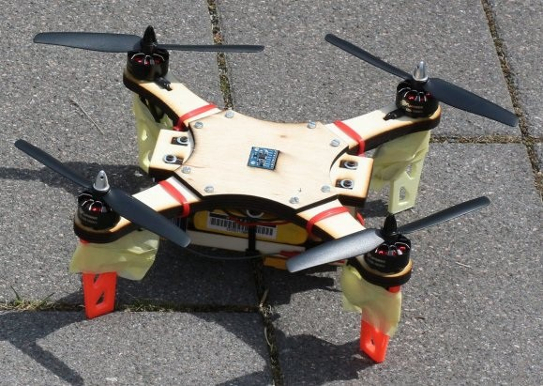

The company needs to design a quadcopter for taking pictures at events and parties.

We selected the electronic and mechanic design, based on Daniele Ingrassia’s satshacopter project, that can be made using two or more digital fabrication technologies, processes and tools.

We recommend the laser cutter to make the frame and packaging, the 3D printer to make a shell for it and the vinyl cutter to complete the box.

The project should include the product concept statement and its documentation in order to easily replicate the product in any lab.

## PRODUCT REQUIREMENTS

Lightweight as possible and less than 0.5 kg, able to carry a gopro camera Attractive and futuristic look

Good picture quality

Easy to control for a newbie

Easy to produce in any lab in maximum 4 hours

## MACHINES AND TOOLS REQUIRED

Laser cutter 3D printer Vinyl cutter Soldering iron

## BILL OF MATERIALS

Plywood and Cardboard Vinyl

Open source flight controller

MPU6050 IMU located exactly at the center 4 x 1900kv brushless motors

4 x 15A ESCs

MultiWii compatible

Hobby King 4 channel remote and receiver 1000mah 3S LiPo battery

The detailed bill of material with purchase link can be found here:

[https://github.com/satshacopter/satshacopter- 250X/raw/master/docs/250X/250X_BOM.xlsx](https://github.com/satshacopter/satshacopter-250X/raw/master/docs/250X/250X_BOM.xlsx)

## Building instructions

Producing the drone itself requires 3-4 days. We recommend to make the drone beforehand so that participants can focus on the enclosure design, marketing and business planning.

The following main tasks are required to assemble the drone:

Laser-cutting the drone frame. [Frame DXF](https://github.com/fablabmade/satshacopter-250X/raw/master/design_files/main_frame_and_supports_8mm.dxf)

[Building and stuffing the Flight Controller Board, see Eagle files and Electronic components BOM](https://github.com/fablabmade/satshacopter-250X/raw/master/docs/250X/250X_BOM.xlsx)

Printing the feet and support using the [3D Printed models](https://github.com/fablabmade/satshacopter-250X/raw/master/design_files/foot.stl)

Assembling the frame and placing ESCs, motors, receiver and Flight Controller board.

Wiring: ESC should be connected now to motors and flight controller. Same applies for the battery and radio receiver. Follow the manual below for wiring instructions.

The project is quite complex, but the author provides a detailed building manual:

[https://github.com/satshacopter/satshacopter-250X/raw/master/docs/250X/satshacopter- 250x-building-manual.pdf](https://github.com/satshacopter/satshacopter-250X/raw/master/docs/250X/satshacopter-250x-building-manual.pdf)

## References

The project is based on Daniele Ingrassia Satshacopter-250 <https://github.com/satshacopter/satshacopter-250X>

# BLUETOOTH MP3 SPEAKER

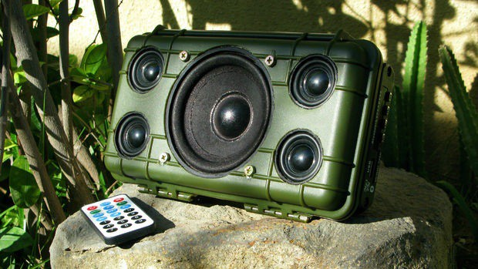

The company is looking for a innovative mp3 / bluetooth speaker which can be easily produced using injection molding processes with different materials, composed of two or more different pieces, in order to minimize part complexity. The product designer must design and prototype their concept proposal based on the preliminary CAD files provided.

The project should include the product concept statement and its documentation in order to easily replicate the product in any lab.

## PRODUCT REQUIREMENTS

Dimensions: 80x80x25mm maximum Low part complexity

Include space for electronics, battery and wiring Allow to insert an SD-card

Provision for recharging the battery Simple button / LED interface

## MACHINES AND TOOLS

3D printer

Laser cutter

Precision CNC Mill, i.e. Roland SRM-20 Soldering iron

## BILL OF MATERIALS

Bluetooth / MP3 board (ready-made) 3W Mono / Stereo Amplifier board Step-up 5V board

Lipo Charger Speaker panels Lipo battery Control panel Buttons Resistors

LEDs

## Building instructions Parts

Bluetooth board

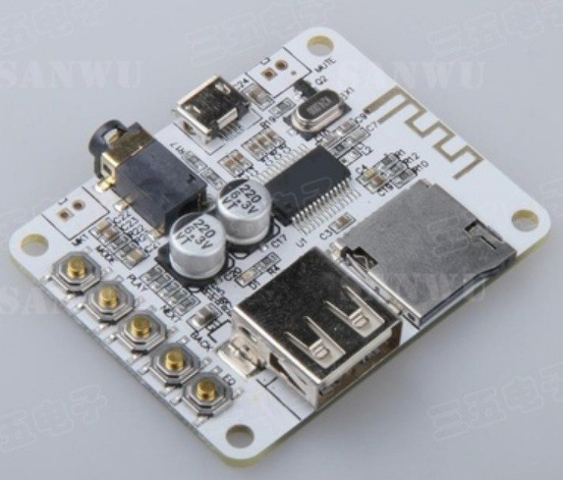

5V Step-up converter

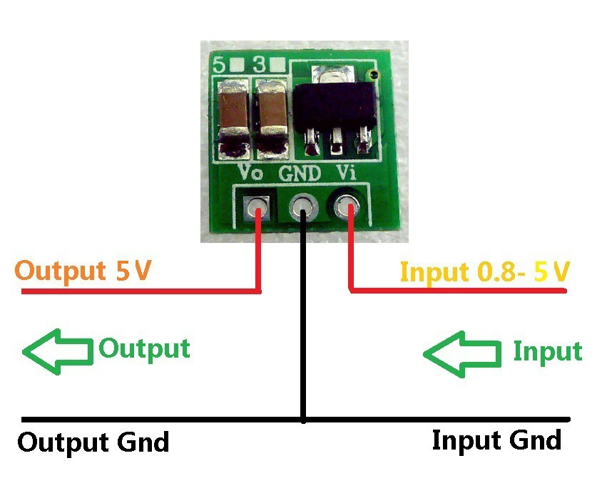

Class D Amplifier

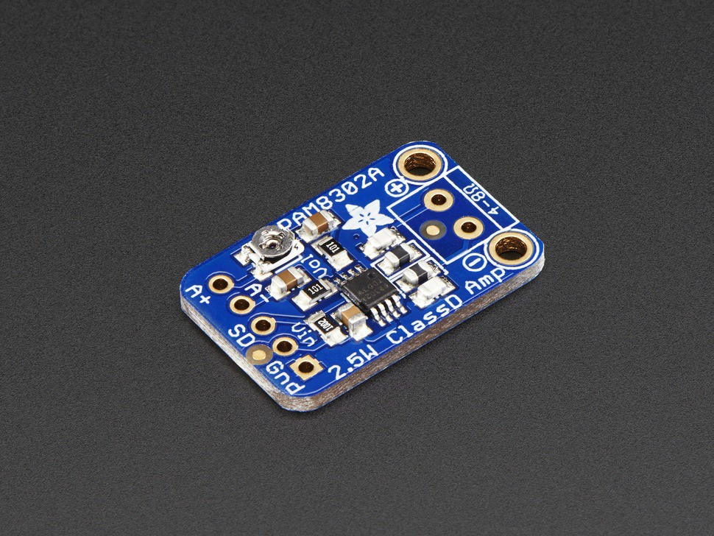

USB Lipo Charger

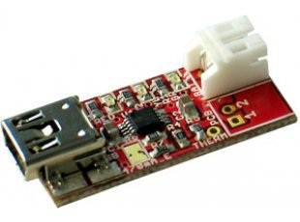

Lipo Battery

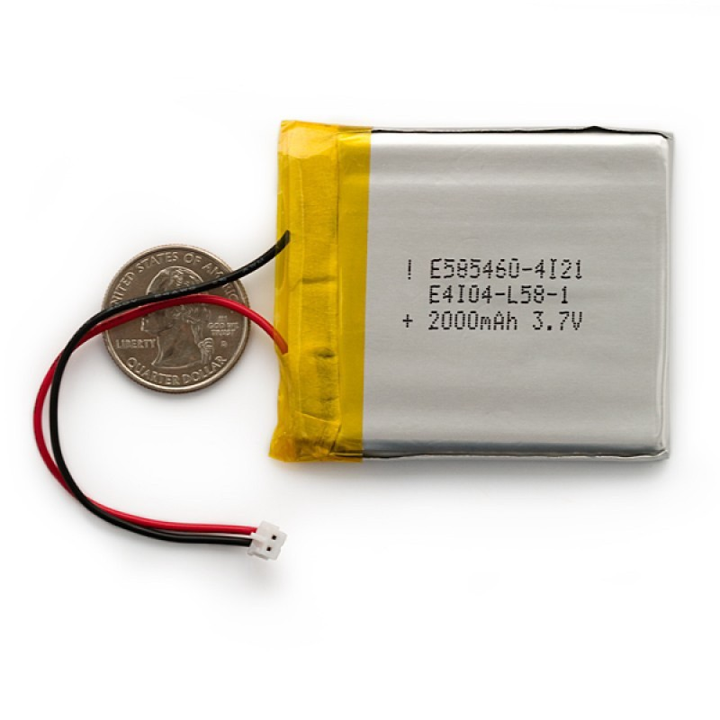

## Wiring

Based on the speaker and amplifier power requirements you will need to select a suitable LiPo battery with enough Amps to last for some time. We recommend to use at least a 2A battery.

Connect the step-up 5V board to the Amplifier and Bluetooth board, using wires to hook up V and Ground. You can solder wires directly on the USB connector pins.

Connect the Lipo Battery to the Charger, and run wires from the Charger to the step up board

Connect the speakers + and - to the amplifier

Build a case around the speaker, you will need to leave ports for connecting the micro USB cable

Optionally you can expose the boards buttons and SD Card slot so you can access the MP3 player functionality. To do so, add buttons to the enclosure and run wires to the original buttons pads. Solder them to replicate the board button functionality.

Same applies to the power LEDs. You can either run wires to the USB connector (remember to add a 1K resistor on one wire) or to the on-board LED indicators (in this case no need to use a resistor)

## Enclosure

The speaker must be encapsulated in a suitable enclosure.

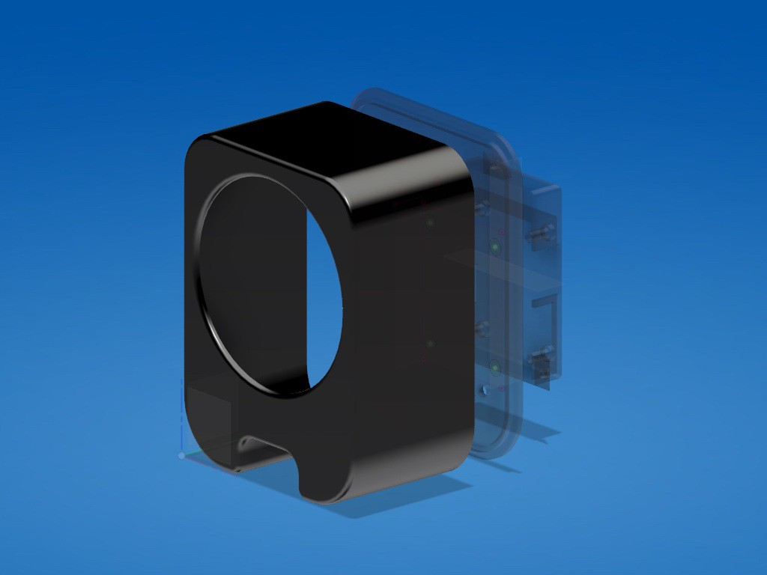

The following options can be proposed to participants:

3D Printed enclosure: You can find models for 3D printing in the shared Fusion 360 Archive BluetoothMP3 Folder, and at the following url: <http://a360.co/2iW1Y79>

Laser-cut enclosure: participants can design a basic box using the [Box Designer](http://boxdesigner.connectionlab.org/) software, then edit the output for creating slots for the electronics and speaker

Recycled - upcycled enclosure. Any metal box can be customized using hand-tools to fit the speaker. Some examples are old suitcases, ammunition boxes, old [telephones, and even Springles cans. For examples and inspiration see: DIY Bluetooth Speaker on Pinterest](https://it.pinterest.com/search/pins/?q=Bluetooth%20Speakers%20diy&amp;rs=typed&amp;term_meta%5B%5D=Bluetooth%7Ctyped&amp;term_meta%5B%5D=Speakers%7Ctyped&amp;term_meta%5B%5D=diy%7Ctyped)

# DIGITAL ASSISTANT

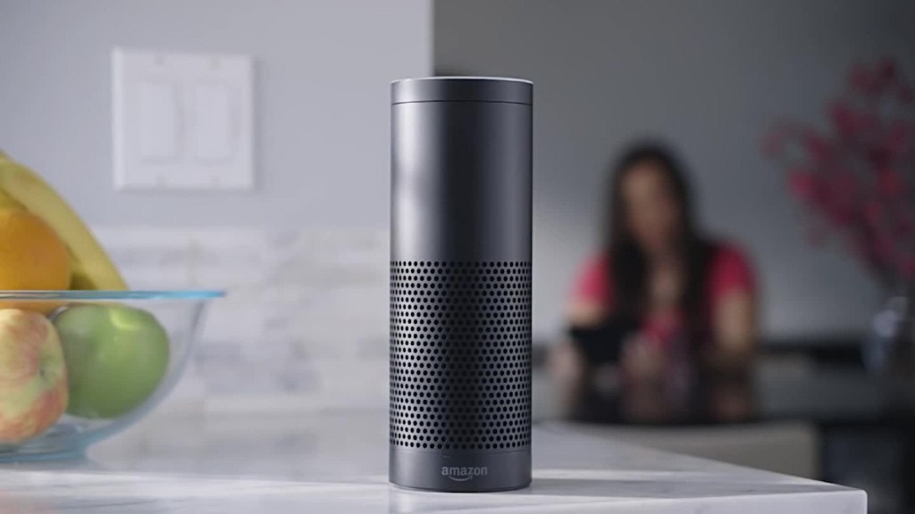

B&R Devices Corporation, Leader in consumer electronics, is looking for a new kind of digital assistant product to launch in 2018.

The target of the product is able to interact with the user using the Amazon Alexa and provide several kind of data including weather, appointments, sport results, movie hours, etc.

The product should be affordable and easy to produce with digital fabrication technologies and processes.

The technology stack used will be based on the Raspberry PI 3, or Chip PRO linux board, that integrates or supports directional microphones and wireless connectivity.

Designers should craft an elegant shell around the electronics, taking into account tolerances and access to the Raspberry / Chip IO ports and power supply.

The final solution should have a retail value of 100 $ or less.

The project should include the product concept statement and its documentation in order to easily replicate the product in any lab.

## PRODUCT REQUIREMENTS

Able to interact with Amazon Alexa using voice commands System activated with a custom Word. Alexa would be the default but customizable Affordable. Its retail value should be 100 $ or less. User friendly Easy to produce in any lab

## MACHINES AND TOOLS

3D printer Laser cutter

Precision CNC Mill, i.e. Roland SRM-20 Soldering iron

## BILL OF MATERIALS

Chip PRO / Raspberry PI 3 USB or integrated Microphone

4-8 ohm Speakers and Stereo amplifier OLED display / LEDS

5V power supply Plywood

ABS / PLA / rubber / cork / wood filament Silicone for molding and casting Machinable wax

Resin for casting

## Building instructions

The hardware assembly shouldn't take more than one hour work. The basic modules are the following:

Controller, for example an Embedded Linux computer, such as [Raspberry PI 3](https://www.raspberrypi.org/products/raspberry-pi-3-model-b/) Audio amplifier and Speaker: you can start from an amplifier module such as [Adafruit 3W stereo amplifier](https://www.adafruit.com/product/987)

Directional Microphone: can be embedded or USB, for example the following [Adafruit USB Microfone](https://www.adafruit.com/product/3367)

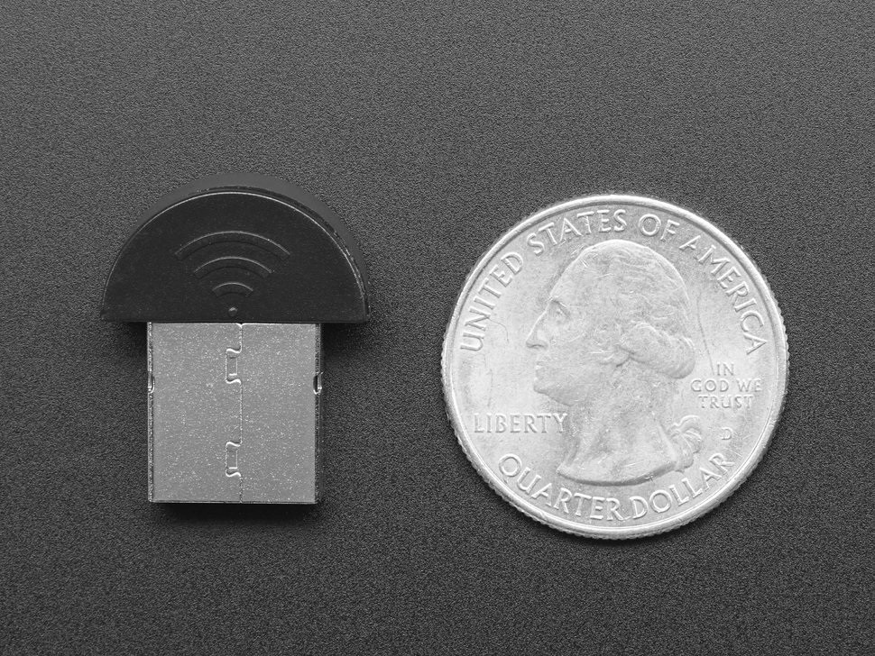

Button and LEDs attached to the controller GPIO Ports:

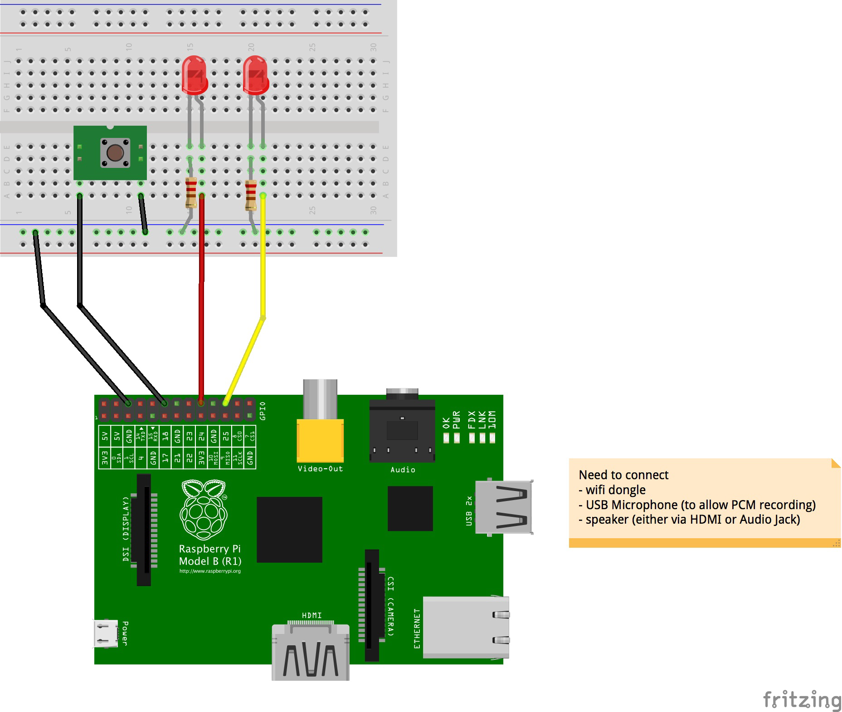

## Enclosure

**Software**

The software stack is based on the Alexa PI open-source project. This is a client for Amazon's Alexa service. It is intended and tested to run on a wide range of platforms, such as Raspberry Pi, Orange Pi, CHIP and ordinary Linux desktops.

NOTE: if you want to setup multiple raspberry at one time, you can install one and clone the microSD card, using the [dd command](https://www.raspberrypi.org/forums/viewtopic.php?t=46911)

The following steps should be followed for the software:

Install a clean [Raspbian Lite installation](https://downloads.raspberrypi.org/raspbian_lite_latest) in a microSD Card as the Raspberry PI operating system. In this case you won't have any GUI. But you can install the full Raspbian which does have XWindows.

Configure the WiFi network: [this tutorial](https://learn.adafruit.com/adafruits-raspberry-pi-lesson-3-network-setup/setting-up-wifi-with-occidentalis) will guide through the setup

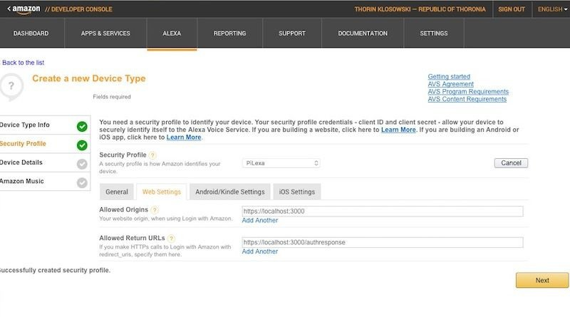[Register an Amazon Account and Install AlexaPI, following the instructions at this link](https://github.com/alexa-pi/AlexaPi/wiki/Installation)

. Make sure you add your Raspberry IP address.

Enter the Amazon credentials you just created in the AlexaPI config file

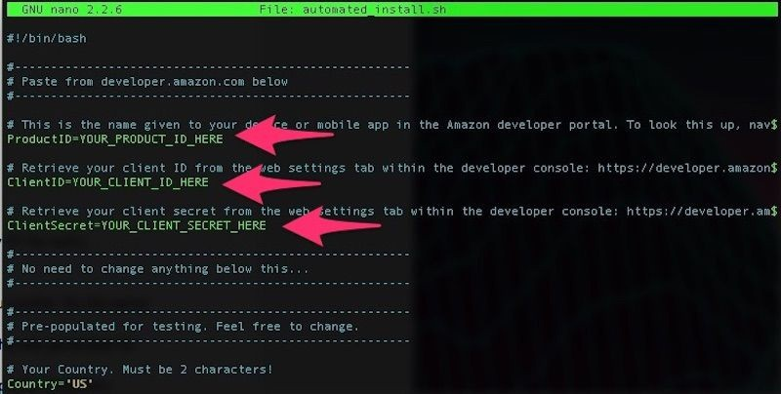 /etc/opt/AlexaPi/config.yaml

Connect speakers and microphone. If the speakers are HDMI setup this option using raspi-config

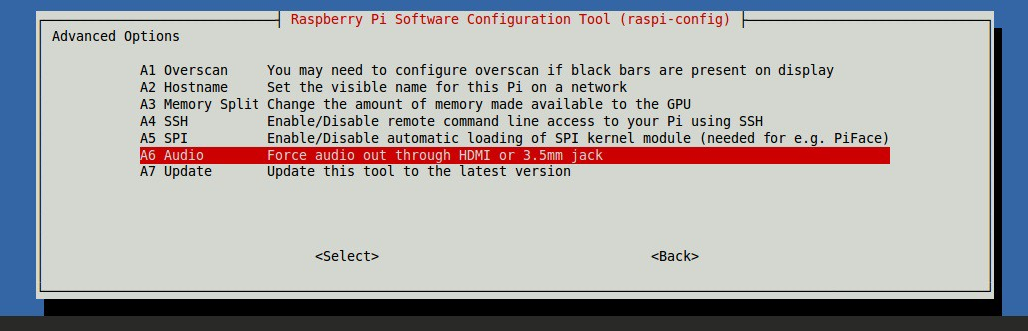

Update the microphone address in the AlexaPi config

/etc/opt/AlexaPi/config.yaml with the output of alsarecord -L . [This page](https://github.com/alexa-pi/AlexaPi/wiki/Audio-setup-%26-debugging) provides instructions for debugging audio)

## References

Alexa PI Project: <https://github.com/alexa-pi/AlexaPi>

# FITNESS TRACKER

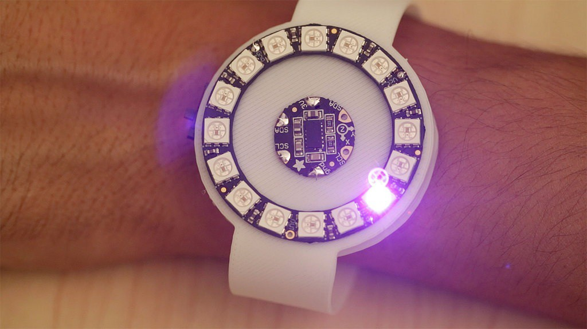

Design, develop and prototype a user-friendly non invasive wearable fitness tracker, suitable for runners and people who regularly workout, but also for normal people who want to track their activity.

The product should be as small and lightweight as possible and easy to wear. The power consumption should be low, to allow at least 12 hours operation.

It should also be waterproof and comfortable to wear, made with soft materials like leather, silicone, rubber and plastics.

We recommend to prototype the product using or combining 3D printing flexible filament and laser cutting technologies or molding and casting processes.

The device should also embed a mini display, and optionally be able to collect and send data via bluetooth.

The project should include the product concept statement and its documentation in order to easily replicate the product in any lab.

## PRODUCT REQUIREMENTS

Lightweight and small as possible

User-friendly Low power Comfortable Waterproof

Made of soft materials (leather, silicone, rubber, plastics). Easy to produce in any lab in maximum 4 hours

## MACHINES AND TOOLS

3D Printer Laser cutter

Precision CNC Mill, i.e. Roland SRM-20 Soldering iron

## BILL OF MATERIALS

Microcontroller (tiny form factor), Flora optionally w/Bluetooth LE module Flora Accelerometer LM303

LIPO battery Flexible filament Leather / Fabric

Silicon and soft rubber for casting Machinable wax

## Build instructions

The project is composed by a mainboard (Adafruit Flora),an accelerometer (Adafruit LM303), and an RGB LED ring (12 Neopixels), a lipo battery and a flexible enclosure.

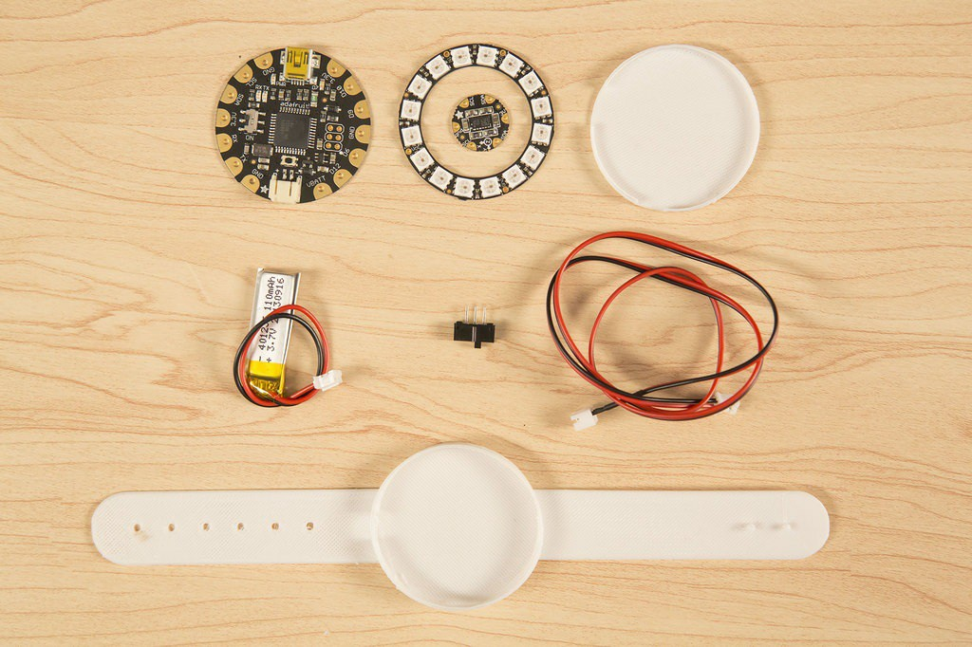

The assembly process should follow this order:

3D Printing the enclosure

Testing and wiring the circuit boards

Uploading the sketch

Perforating the enclosure to run wires

Integrating the parts together

## 3D Printing

You can produce a full enclosure using the NinjaFlex filament using a standard 3D Printer.

The following files can serve as a starting point for the project: https://www.thingiverse.com/thing:221609

NOTE: The best temperature for printing NinjaFlex on the ultimaker is 225 degrees. Also you should set 105% flow for best surface finishing.

## Wiring

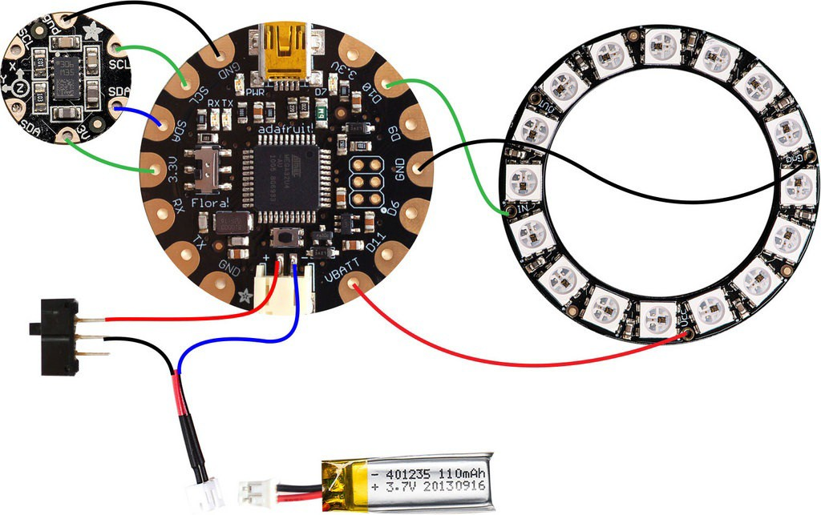

The wiring should connect the three boards together, the accelerometer needs GND, 3V, SCL, SDA to talk to the Flora ATMega328p using the I2C (TwoWire) protocol.

The Neopixel ring can be addressed via the D10 Flora Pin, using the Neopixel's onewire protocol. You need to connect the D10 to the In pin on the Neopixel Ring, then VBAT to VCC, and GND to GND on the ring.

Power will be given by a Lipo 3.7v battery connected to the Flora.

## Programming

The programming of the project can be done using the Arduino IDE.

### Preparation

You need to add support to the various boards through the Arduino Board manager and add the required libraries using the Library Manager.

1. Add Adafruit Flora to the boards supported by Arduino: Open Arduino and select the menu File > Preferences
2. Set the following URL in the "Additional Boards Manager URL" field:<https://adafruit.github.io/arduino-board-index/package_adafruit_index.json>
3. Open the Board manager using the Tools->Board->Board Manager menu
4. Search for Adafruit AVR Boards and click Install on the bottom right
5. Now add the libraries: Sketch menu, > Include Library > Manage Libraries... and

add the following Libraries: Adafruit NeoPixel by Adafruit Adafruit GFX Library

Wire Adafruit_LSM303

### Working with the accelerometer

The accelerometer is a digital sensor, so it must be initialized before using. The data read from the accelerometer include a vector (x,y,z) with the relative acceleration at a given time.

In order to process this information we can use different approaches of increasing complexity, including [Hidden Markov Models](http://www.dcs.gla.ac.uk/%7Ejhw/gesturehmm.html), [DWT](https://en.wikipedia.org/wiki/Dynamic_time_warping) and other kins of classifiers.

These methodologies require a **training** session to be done beforehand, and use the acquired sample data for comparing if a sensor's reading can be considered a gesture or not.

For the sake of simplicity and also according to the not so powerful ATMega328p specs, we will just measure the differences between discrete readings of the sensor and set a threshold from which we start recognizing if there was a movement or not.

### Code

The following code measures the overall amplitude of a movement in all axes and flashes the LEDs accordingly.

The exercise is to modify the code to count the steps using the same technique, then light the LEDs in sequence for groups of 10 steps.

#include <Wire.h>

#include <Adafruit_LSM303.h>

#include <Adafruit_NeoPixel.h>

// Parameter 1 = number of pixels in strip

// Parameter 2 = pin number (most are valid)

// Parameter 3 = pixel type flags, add together as needed:

// NEO_RGB Pixels are wired for RGB bitstream

// NEO_GRB Pixels are wired for GRB bitstream

// NEO_KHZ400 400 KHz bitstream (e.g. FLORA pixels)

// NEO_KHZ800 800 KHz bitstream (e.g. High Density LED strip) Adafruit_NeoPixel strip = Adafruit_NeoPixel(16, 10, NEO_GRB + NEO_KHZ800); Adafruit_LSM303 lsm;

// Here is where you can put in your favorite colors that will appear!

// just add new {nnn, nnn, nnn}, lines. They will be picked out randomly

// R G B

uint8_t myFavoriteColors[][3] = {{200, 0, 200}, // purple

{0, 117, 255}, // blue

{200, 200, 200}, // white

};

// don't edit the line below

#define FAVCOLORS sizeof(myFavoriteColors) / 3

// mess with this number to adjust TWINklitude :)

// lower number = more sensitive

#define MOVE_THRESHOLD 300

void setup()

{

Serial.begin(9600);

// Try to initialise and warn if we couldn't detect the chip if (!lsm.begin())

{

");

}

Serial.println("Oops ... unable to initialize the LSM303. Check your wiring! while (1);

strip.begin();

strip.show(); // Initialize all pixels to 'off'

}

void loop()

{

// Take a reading of accellerometer data lsm.read();

Serial.print("Accel X: "); Serial.print(lsm.accelData.x); Serial.print(" "); Serial.print("Y: "); Serial.print(lsm.accelData.y); Serial.print(" "); Serial.print("Z: "); Serial.print(lsm.accelData.z); Serial.print(" ");

// Get the magnitude (length) of the 3 axis vector

// <http://en.wikipedia.org/wiki/Euclidean_vector#Length> double storedVector = lsm.accelData.x*lsm.accelData.x; storedVector += lsm.accelData.y*lsm.accelData.y; storedVector += lsm.accelData.z*lsm.accelData.z; storedVector = sqrt(storedVector);

Serial.print("Len: "); Serial.println(storedVector);

// wait a bit delay(100);

// get new data! lsm.read();

double newVector = lsm.accelData.x*lsm.accelData.x; newVector += lsm.accelData.y*lsm.accelData.y; newVector += lsm.accelData.z*lsm.accelData.z;

newVector = sqrt(newVector);

Serial.print("New Len: "); Serial.println(newVector);

// are we moving

if (abs(newVector - storedVector) > MOVE_THRESHOLD) { Serial.println("Twinkle!");

flashRandom(5, 1); // first number is 'wait' delay, shorter num == shorter twinkle

flashRandom(5, 3); // second number is how many neopixels to simultaneously light up

flashRandom(5, 2);

}

}

void flashRandom(int wait, uint8_t howmany) {

for(uint16_t i=0; i<howmany; i++) {

// pick a random favorite color! int c = random(FAVCOLORS);

int red = myFavoriteColors[c][0]; int green = myFavoriteColors[c][1]; int blue = myFavoriteColors[c][2];

// get a random pixel from the list int j = random(strip.numPixels());

//Serial.print("Lighting up "); Serial.println(j);

// now we will 'fade' it in 5 steps for (int x=0; x < 5; x++) {

int r = red * (x+1); r /= 5; int g = green * (x+1); g /= 5; int b = blue * (x+1); b /= 5;

strip.setPixelColor(j, strip.Color(r, g, b)); strip.show();

delay(wait);

}

// & fade out in 5 steps for (int x=5; x >= 0; x--) {

int r = red * x; r /= 5; int g = green * x; g /= 5; int b = blue * x; b /= 5;

strip.setPixelColor(j, strip.Color(r, g, b)); strip.show();

delay(wait);

}

}

// LEDs will be off when done (they are faded to 0)

}

## References

This project is based on [Adafruit Flora tutorial](https://learn.adafruit.com/3d-printed-flora-band)

# BRIGHT JEWEL

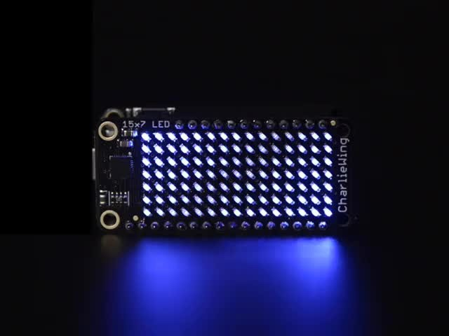

The Jewellery Company Leader Delta is looking for an innovative and atypical jewel in order to launch a new collection of bright jewels suitable for males and females. The product can be an innovative ring, a bracelet, a necklace but also an accessory.

There is no limit to the shape and the size of the jewel. It should only embed the electronics and emit light with a programmable pattern. Particular attention should be paid to the aesthetics and materials of the proposed design concept.

Designer should develop and prototype their jewel proposal using digital fabrication technologies. We recommend to prototype the product using or combining 3D printing and molding and casting processes.

The project should include the product concept statement and its documentation in order to easily replicate the product in any lab.

## PRODUCT REQUIREMENTS

Easily replicable in any lab in maximum 4 hours Suitable for male and female

Fancy lighting effects Elegant materials

## MACHINES AND TOOLS

3D Printer Laser cutter

Precision CNC Mill, i.e. Roland SRM-20 Soldering iron

## BILL OF MATERIALS

[Adafruit Feather w/ ATMega 328p](https://www.adafruit.com/product/2771)

Adafruit Feather Wing with charlie-plexed LEDs LIPO battery

Push-Buttons Silicone for molding Resin for casting Machinable wax

## Build instructions

The project is composed by two modules:

Electronics boards + LED array and LiPo Battery

Enclosure and pendant: this could be a 3D Printed Case, a Laser Cut box, or a molded container

## Assembling the Electronics

The two boards are made to be stacked on top of each other. Before that you must [solder the headers to the Feather. For minimum size it's better to use the low profile headers kit](https://www.adafruit.com/product/2940)

Stack the Feather Wing on top of the Feather and connect the LiPo Battery to the Feather.

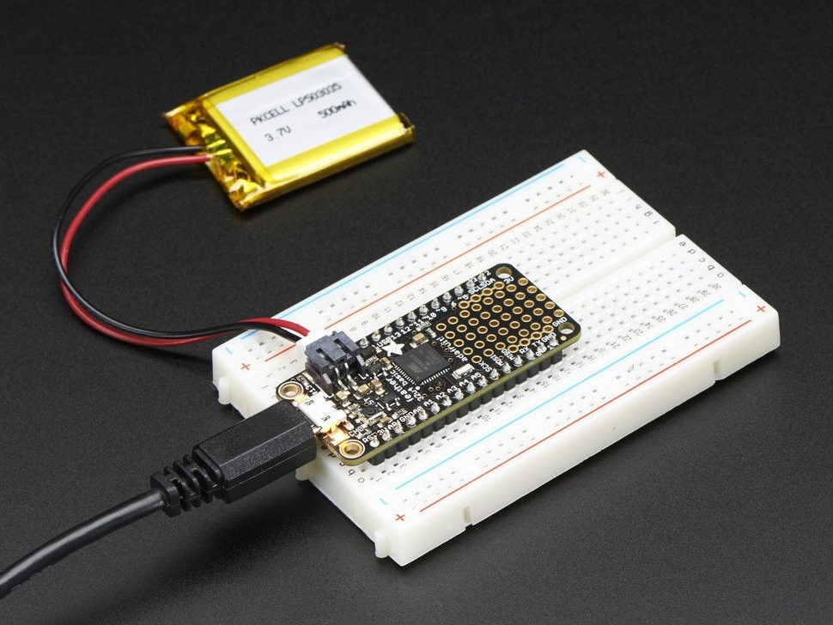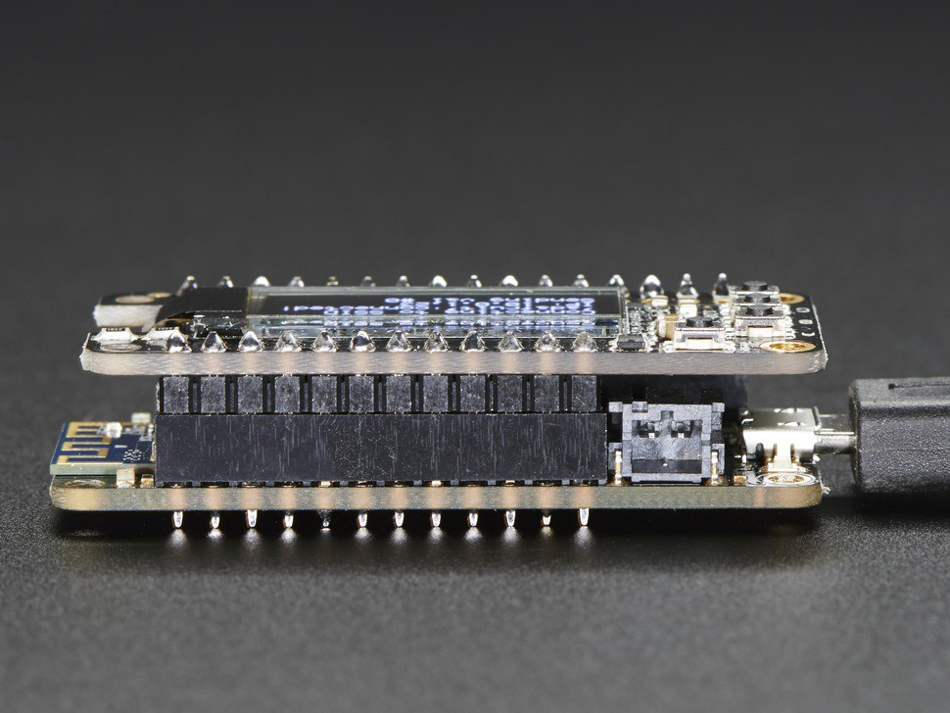

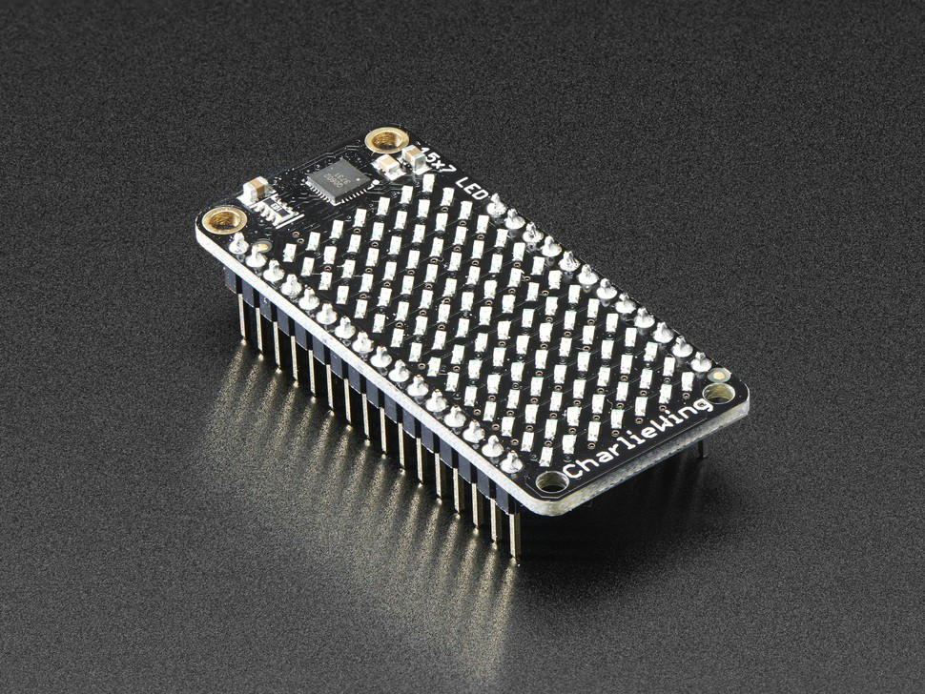

## Programming

### Preparation

Add Adafruit AVR Boards to the Arduino IDE like shown in the previous projects. Add the required libraries:

[Adafruit_IS31FL3731](https://github.com/adafruit/Adafruit_IS31FL3731/archive/master.zip)

[Adafruit GFX](https://github.com/adafruit/Adafruit-GFX-Library/archive/master.zip)

Load the Demo sketch: File->Examples->Adafruit_IS31FL3731->featherswirldemo

In order to work with the Charlieplexing FeatherWing uncomment the second line so it look like the following:

// If you're using the full breakout...

//Adafruit_IS31FL3731 matrix = Adafruit_IS31FL3731();

// If you're using the FeatherWing version Adafruit_IS31FL3731_Wing matrix = Adafruit_IS31FL3731_Wing();

### Exercise

You can modify the sketch to draw any pattern or bitmap.

The library allows to do both with the drawPixel() and drawBitmap() functions. The Bitmap is stored into an array of bytes each representing a pixel.

You can also regulate the intensity of each pixel using the setColor() function. Finally the library allows to draw scrolling text using the print() function.

## Enclosure

A basic enclosure is provided for the Adafruit Feather. Start from the [Fusion 360 design](http://a360.co/2nK42AQ).

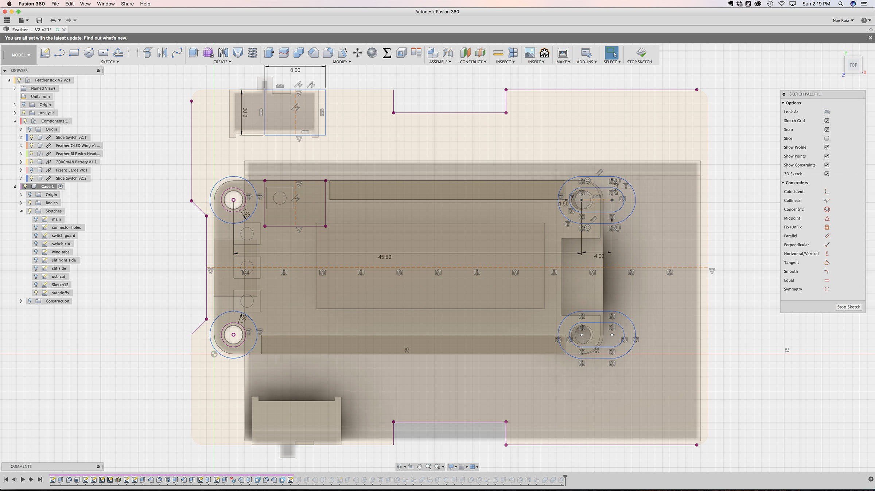

# SMART WATCH

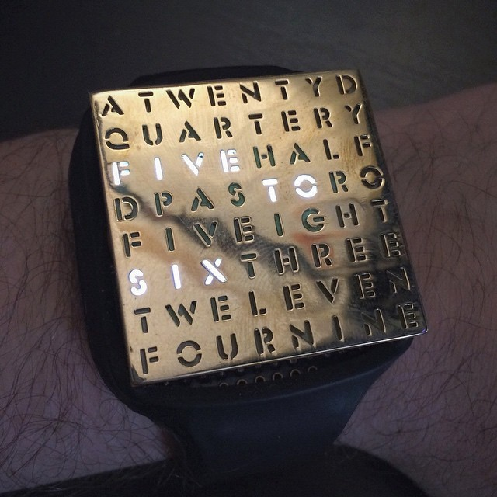

CLOK Company is looking for a new affordable kind of smartwatch to develop in 2018.The product should be suitable for kids and comfortable to wear. It should look fancy and attractive, but extremely easy to use.

Designer should develop and prototype their concept proposal including the design of the clock and its band, starting from the Adafruit Watch kit provided but fully customizing shape and size. Particular attention should be paid to the aesthetics and ergonomics and the materials of the proposed design concept.

Designer should develop and prototype their proposal using digital fabrication technologies and processes. We recommend to prototype the product using or combining 3D printing, laser cutting and molding and casting processes.

The project should include the product concept statement and its documentation in order to easily replicate the product in any lab.

## PRODUCT REQUIREMENTS

Easily replicable in any lab in maximum 4 hours Suitable for kids, male and female

Very easy to use

Fancy and attractive look Affordable

Comfortable

## MACHINES AND TOOLS

3D Printer Laser cutter

Precision CNC Mill, i.e. Roland SRM-20 Soldering iron

## BILL OF MATERIALS

8x8 ultra-bright red matrix display ATmega328P chip with Arduino Bootloader DS1337 real time clock

CR2032 coin cell included Silicone for molding and casting Leather

## Building instructions

For building the project we create a variant that uses LEDs that contains letter. This way the time is spelled in words.

For building the watch we need to:

Solder the TimeWatch kit components (see the [tutorial](https://learn.adafruit.com/timesquare-watch-kit/kit-assembly))

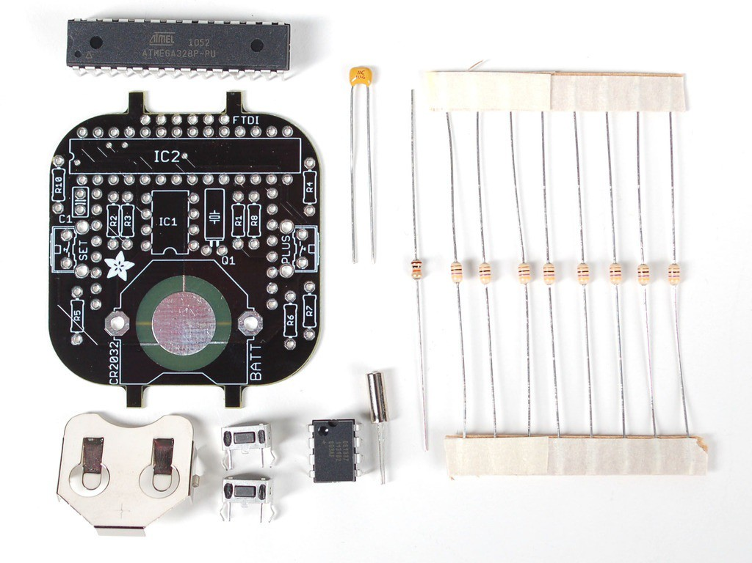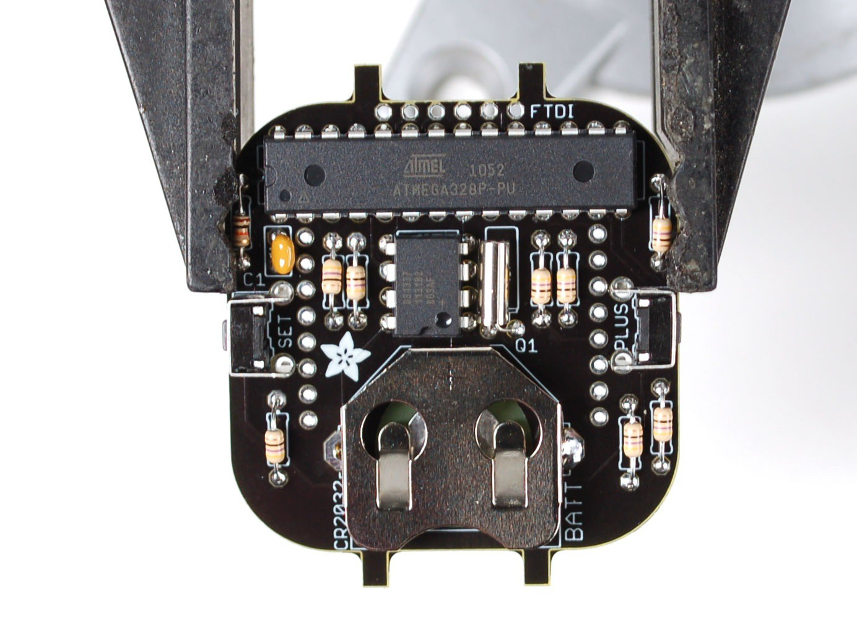

The LED matrix should be soldered on the bottom of the board, with the Text in the same direction as the arrow:

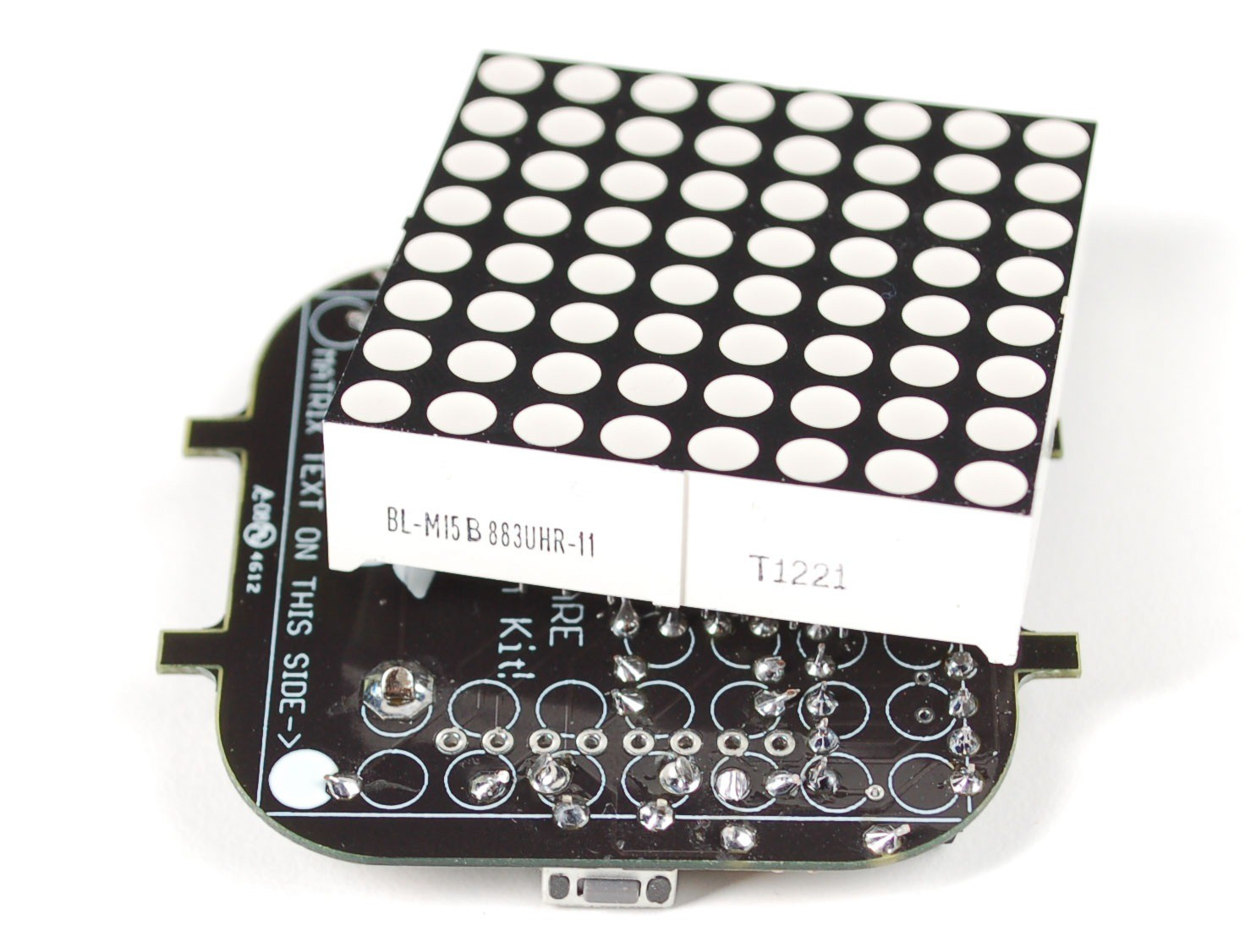

Laser-cut the Word frame on veneer wood or other opaque material. Use the provided [DXF File](https://github.com/fablabmade/Wordclock-Wristwatch/raw/master/faceplates%20%26%20housing/wordclock_faceplate_ponoko.dxf) as a starting point

Program the board

Assemble the kit

## Programming

### Preparation

The watch must be programmed using an FTDI Cable / Adapter such those used for Fab Academy Hello Echo board.

Solder the FTDI Headers in the TimeWatch board and connect a cable like this:

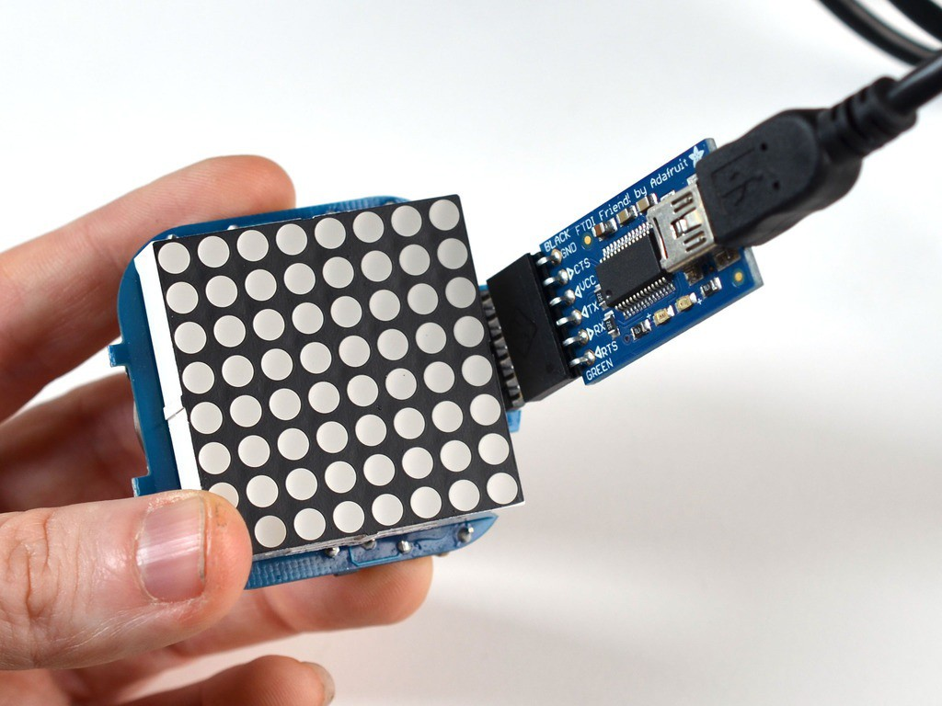

You also need to install the required libraries, and if you didn't before the driver for the [FTDI Cable](http://www.ftdichip.com/FTDrivers.htm):

[Adafruit GFX Library](https://github.com/adafruit/Adafruit-GFX-Library) [RTClib](https://github.com/adafruit/RTClib)

### Upload the Word Watch Sketch

You can find the source at the following url: <https://github.com/fablabmade/Wordclock-Wristwatch>

Download the Zip file and rename it as Watch in the Documents>Arduino>Libraries folder.

Open the Arduino IDE and select Examples > Watch > WordclockWatch Program the board selecting the Board as a **LilyPad Arduino with ATmega328**. **Exercise**

Change the Sketch to show the time in another alphabet.

# WIFI WEATHER STATION

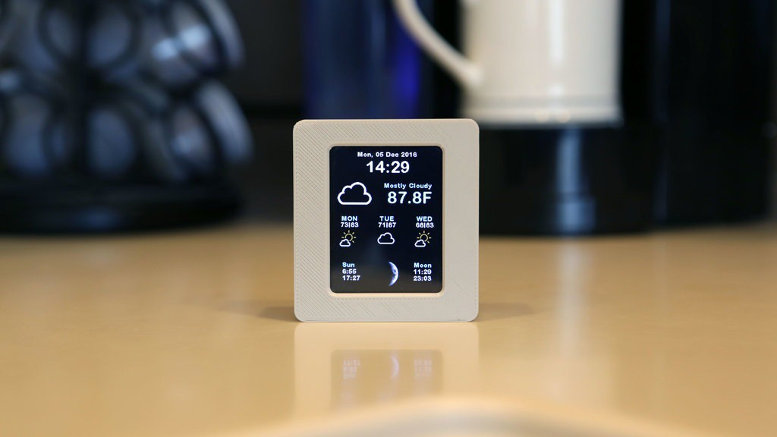

CLOUD Company is looking for a new wifi weather station product. This will allow to monitor and display weather conditions on a screen. It should display the date, time, current weather conditions, 4-day forecast and even moon phases.

The product should be affordable and easy to produce with digital fabrication technologies and processes, in order to have a retail value of 80 $ or less.

The technology stack will be based on Adafruit components and the Wunderground API using an ESP8266 microcontroller and a 2.4" TFT touchscreen display. Designers should prototype a fancy shell for the product to embed the electronics.

The project should include the product concept statement and its documentation in order to easily replicate the product in any lab.

## PRODUCT REQUIREMENTS

User friendly

Attractive, with an hi-tech look suitable to be put on an office desk or in the house Easy to produce in any lab in 4 hours maximum

Portable and lightweight

## MACHINES AND TOOLS

3D Printer Laser cutter

Precision CNC Mill, i.e. Roland SRM-20 Soldering iron

## BILL OF MATERIALS

2.4" TFT Feather Wing 320x240 Touch screen

Adafruit Feather HUZZAH with ESP8266 WiFi (<http://adafru.it/2821>) 2000mAh Rechargeable Battery (<http://adafru.it/2011>)

Slide Switch (<http://adafru.it/805>) ABS / PLA Filament

Silicon for molding Resin for casting Machinable wax

## Building instructions

The project is extremely easy to assemble thanks to the integrated boards of the Adafruit Feather series.

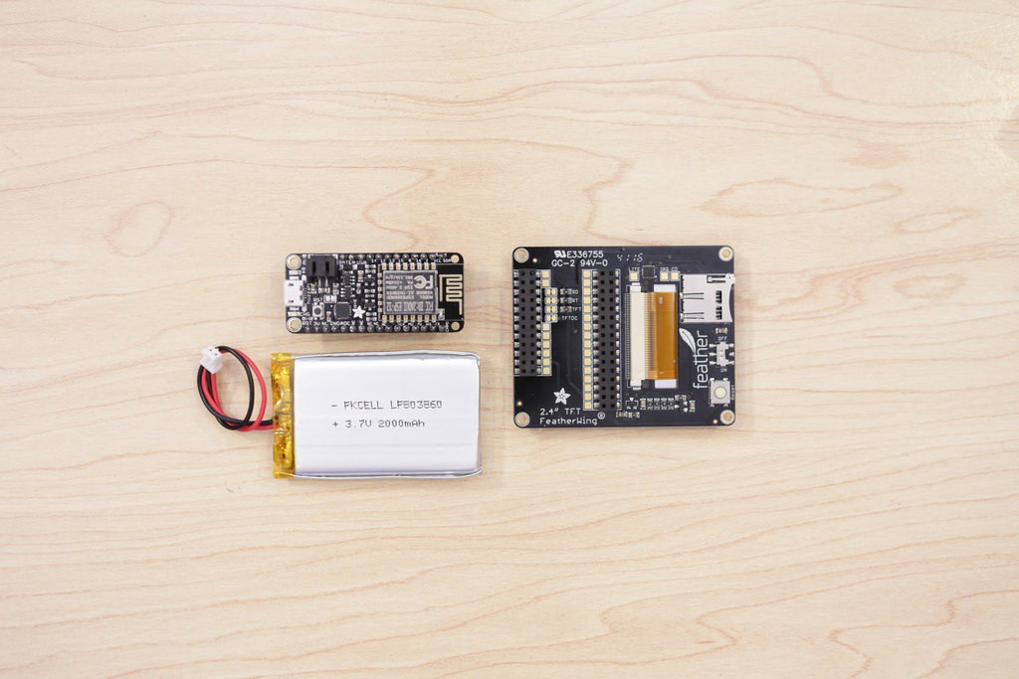

You need to connect the display and attach the battery to complete the assembly. Optionally you can include a switch for disconnecting one of the battery wires when the device is off.

## 3D Printing

You can start your design from these models on Thingiverse or use the Fusion 360 design in the shared folder (IOT projects).

## Programming

Programming the board can be done with the Arduino IDE.

### Preparation

You need to add support for the [Adafruit ESP8266 board](https://learn.adafruit.com/adafruit-feather-huzzah-esp8266/using-arduino-ide) and [Display / TouchScreen](https://learn.adafruit.com/adafruit-2-4-tft-touch-screen-featherwing) and install the required libraries in the Arduino IDE, either manually or using the Library manager:

[Adafruit GFX Library](https://github.com/adafruit/Adafruit-GFX-Library) [Adafruit ILI9341 Library](https://github.com/adafruit/Adafruit_ILI9341) [Adafruit STMPE610](https://github.com/adafruit/Adafruit_STMPE610) [WiFiManager for ESP8266](https://github.com/tzapu/WiFiManager)

[ESP8266 Weather Station Library](https://github.com/squix78/esp8266-weather-station) [JSON Streaming Parser](https://github.com/squix78/json-streaming-parser)

You will also need the free [Wunderground API Key](https://www.wunderground.com/weather/api/d/pricing.html) for the weather forecast API. The Software sketch can be downloaded at the following git repository: <https://github.com/fablabmade/weather-station-color>

Download the sketch and later upload it through the Arduino IDE. Before uploading update the settings.h file:

// Wunderground Settings

const boolean IS_METRIC = true;

const String WUNDERGRROUND_API_KEY = "68b21a1a4d573729"; const String WUNDERGRROUND_LANGUAGE = "EN";

const String WUNDERGROUND_COUNTRY = "UAE";

const String WUNDERGROUND_CITY = "Dubai";

You can replace the Key with your own received from Wunderground.

The software will put the device in sleep mode after 5s use. Touching the screen can wake up the device. This allows few hours of operation without recharging.

***References***

Project based on [ESP8266 Weather Station](https://learn.adafruit.com/wifi-weather-station-with-tft-display/overview) and Daniel Eichhorn @ [http://blog.squix.ch](http://blog.squix.ch/)

# MAGIC MIRROR

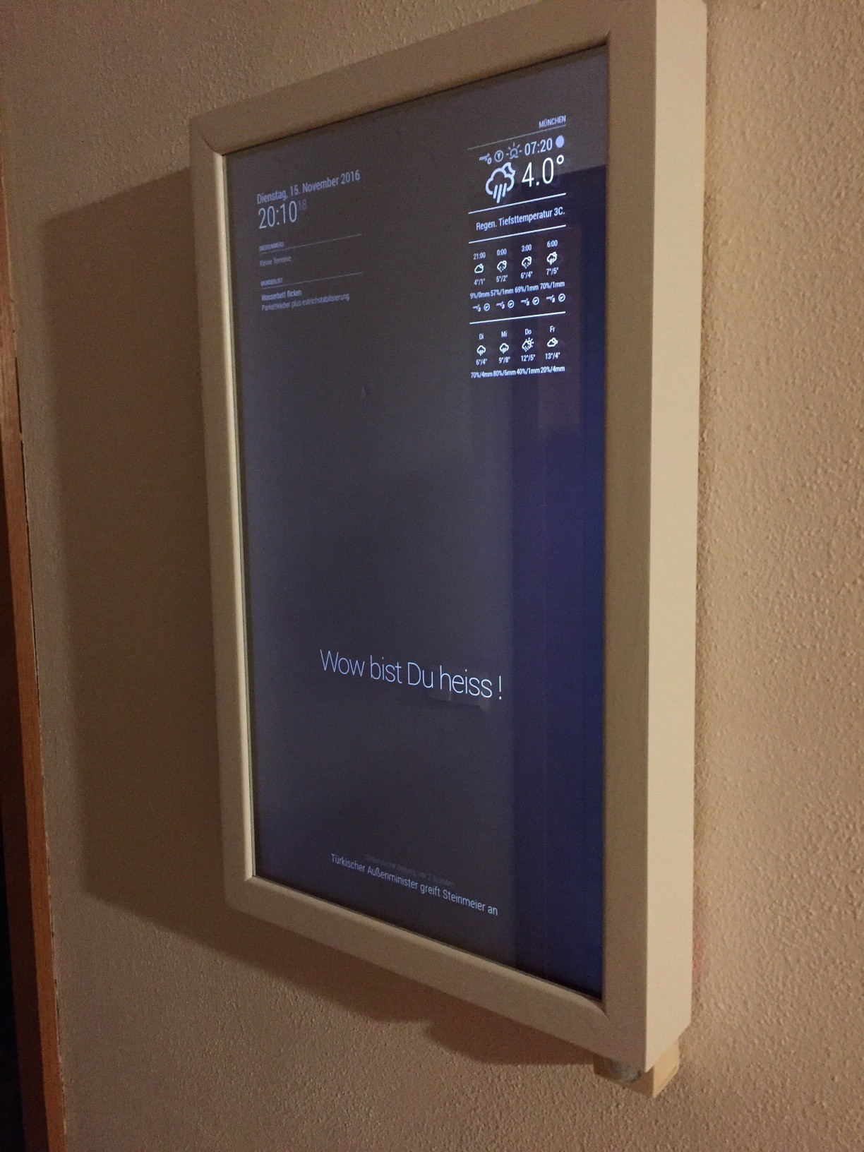

Mirrora company wants to launch a new interactive mirror that adds dynamic information to the classic room mirror.

The underlying hardware will include a Raspberry 3 computer and a barebones LCD monitor of 10’’. The software will allow to visualize information such as time and date, weather reports, news feed and calendar, based on the MagicMirror 2 open source project.

Designers should prototype a frame and fancy shell for the product to embed the electronics using the laser cutter.

The project should include the product concept statement and its documentation in order to easily replicate the product in any lab.

## PRODUCT REQUIREMENTS

User friendly Attractive Easy to produce in any lab in 4 hours maximum

## MACHINES AND TOOLS

3D Printer Laser cutter Soldering iron

## BILL OF MATERIALS

LCD Monitor 10-15’’

Raspberry PI 3 Mirror silver vinyl Plywood / Plexiglass

## Building instructions

The main modules are:

Raspberry PI 3

Monitor or TV of suitable size with HDMI Output

Picture frame of suitable size, thick enough to hide the Monitor See-thru film or spy mirror (such as those used in cars)

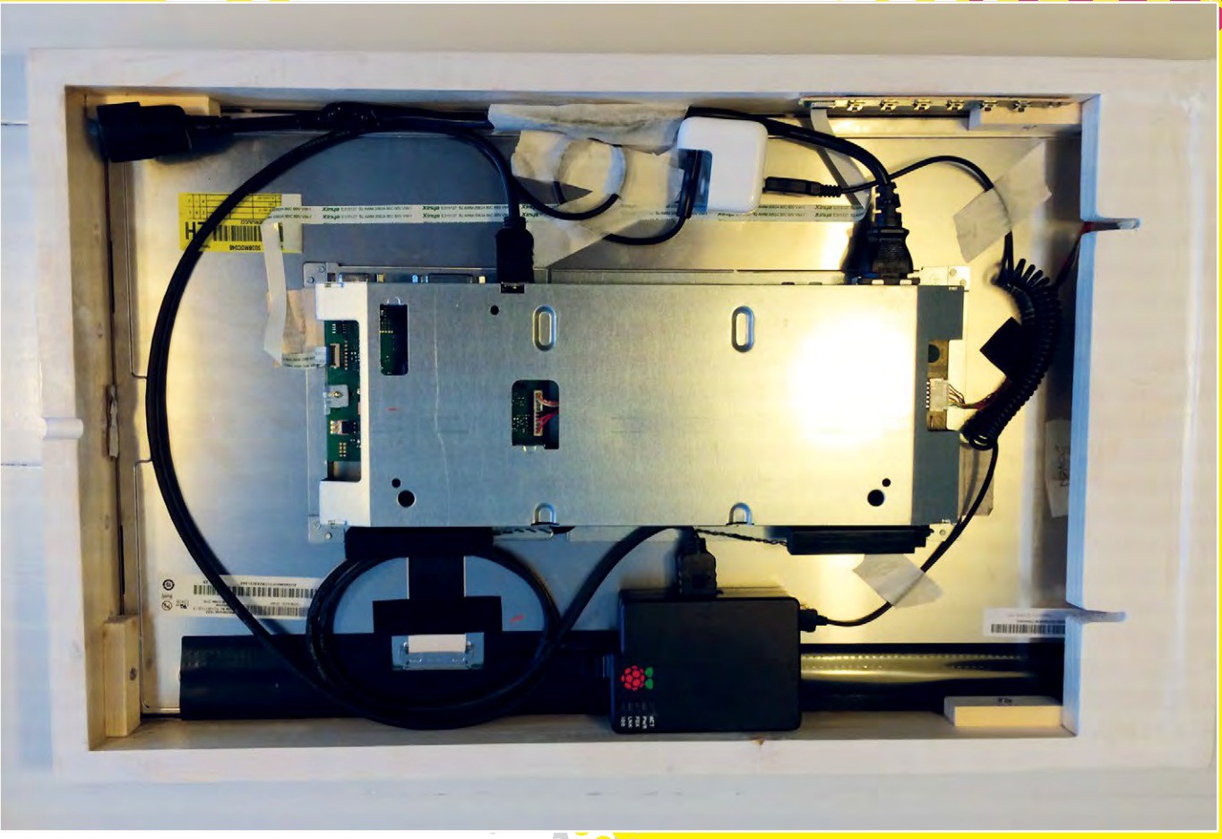

You need to fix the TV or Monitor inside the Picture frame, in a way that the monitor is not visible any more. You should leave enough space to also fit the Raspberry PI 3 and make a hole for the power cable for screen and Raspberry (you can also use a powerbank to power the raspberry, but not the TV).

Once you have everything working, apply the spy film on the mirror and test the visibility, you might need to change the luminosity and contrast of your monitor for best results. In alternative it is possible to get an acrylic two-way mirror. In either case you need to measure the size of the existing picture frame for exact dimensions.

## Power cable

Tip: for best results you can open an USB Charger and run the monitor power wire through it in order to have a powered 5V USB port ready for the Raspberry and a single cable hanging out of the mirror.

For a really clean job you can put a power port on one side of the mirror: You need to look for ["c13 IEC cord 10 amps"](https://en.wikipedia.org/wiki/IEC_60320#C13.2FC14_coupler)

This is one type:

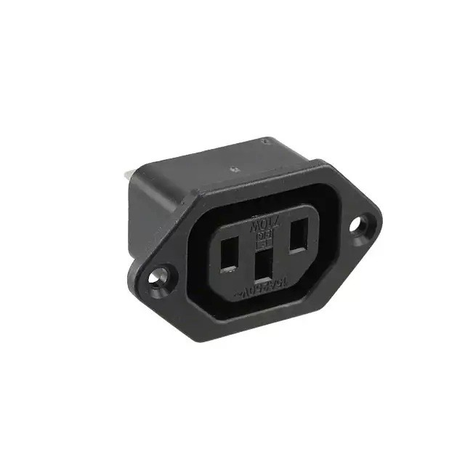

<https://www.digikey.it/product-detail/it/qualtek/710W-00-03/Q223-ND/245564>

## Software

The Magic Mirror is based on the [MagicMirror2 open source project](https://github.com/MichMich/MagicMirror) which provides a number of ready-made widgets as well as an API to build your own.

## Loading the software

For the software side you need to prepare an SD Card for the Raspberry PI. This should be a basic Raspbian image.

Configure the Raspberry PI 3 Wireless network and connect to a shell, described in the Digital Assistant guide, you will now edit the boot config to rotate the screen:

$ sudo nano /boot/config.txt

Look for the following labels or add them if they are not there:

display_rotate=1 avoid_warnings=1

Diable the power saving for the wireless card (causes lock-ups)

sudo nano /etc/network/interfaces

And add the following line after the wlan0 section ()

sudo wireless-power off

Reboot the raspberry

``sudo shutdown -r now

Finally type in the following to install Magic Mirror:

curl -sL <http://magpi.cc/MirrorInstall> | bash

Configure the options:

cp ~/MagicMirror/config/config.js.sample ~/MagicMirror/config/config.js nano ~/MagicMirror/config/config.js

You can set the following:

port: the port where you can connect to the smart mirror ex. http://:port zoom: the zoom factor for the interface

language

timeFormat: 12 or 24 hours units: metric or imperial

In the article linked in the reference you find other options for customizing the interface.

## Modules

The following modules are installed by default.

Clock Calendar

Current Weather Weather Forecast News Feed Compliments Hello World

Alert

You can add 3rd party or custom modules using the shell (or SSH) cloning them from git into the ~/MagicMirror/modules folder.

Contributed modules are available at the following URL: <https://github.com/MichMich/MagicMirror/wiki/MagicMirror%C2%B2-Modules>

## References

[MagicMirror2 open source project](https://github.com/MichMich/MagicMirror)

[MagPI issue 54: Make your own Magic Mirror pp.14](https://www.raspberrypi.org/magpi-issues/MagPi54.pdf)

# SECURITY CAM

H.I.D.E.. Company is looking for produce a new affordable kind of security camera suitable to control babies in the house. The camera should work in the darkness and notify when some movement happens.

The task of Designer is to develop and prototype a shell to embed the cam and the electronics using digital fabrication technologies and processes.

The product should be as small as possible and completely made of plastics. We recommend to use 3D printing technology or molding and casting processes to prototype the product.

## PRODUCT REQUIREMENTS

Affordable. Its retail value should be 80 $ or less Easy to produce in any lab in 4 hours maximum Made of plastics

## MACHINES AND TOOLS

3D Printer Laser cutter

Precision CNC Mill, i.e. Roland SRM-20 Soldering iron

## BILL OF MATERIALS

[Adafruit Feather Adalogger](https://www.adafruit.com/product/2795) Security JPEG Camera MicroSD Card

ABS / PLA Filament

## Building instructions Wiring the camera

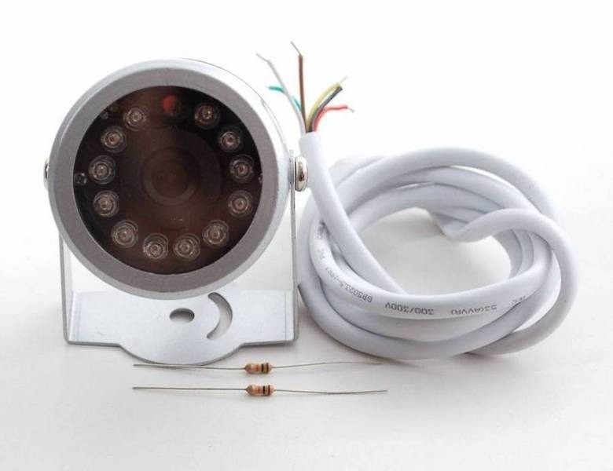

Red is connected to +5V in Black is connected to Ground Green is RX

White is TX

Yellow is NTSC Video signal out Brown is NTSC Video ground

You can connect the RX to the TX pin of Arduino, and vice-versa. But you will loose the ability to control the Arduino with the Serial Console. In alternative you can use the [SoftwareSerial Library](https://www.arduino.cc/en/Reference/SoftwareSerial) to use arbitrary pins.

### Testing the camera

You can solder an RCA female pin to the Yellow-Brown cables and attach the camera to an old TV

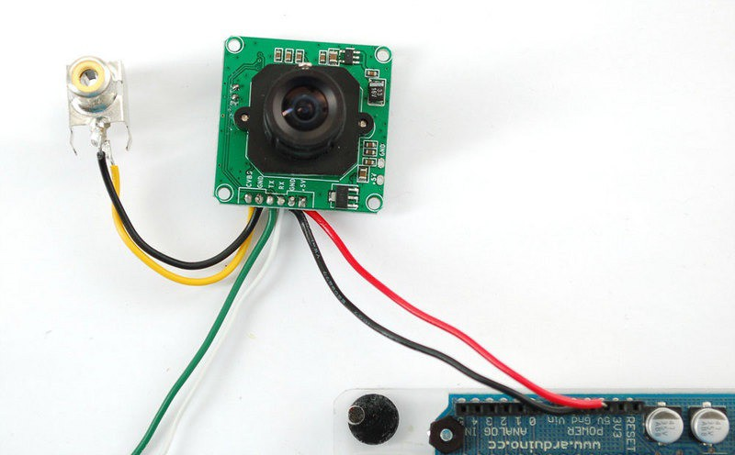

Another test is connecting the RX, TX, 5V and GND wires to an FTDI Cable. Then use the following Windows software to connect and configure the camera:

[VC0706 Comm Tool - Windows control software](http://www.adafruit.com/datasheets/VC0706CommTool(EN)%20Setup%20V1-00.exe)

Tip: If the connection doesn't work You might have to swap the green and white wires

For Linux is possible to take a picture with the camera using the following python [script](https://raw.githubusercontent.com/adafruit/Adafruit-VC0706-Serial-Camera-Library/master/getimage0706.py), works great on a Raspberry PI for example.

## Wiring the SD Card adapter

If you are not using the Adafruit Feather Adalogger board, but a normal Arduino you might need to wire the SD Card Adapter and test it with the provided example from the producer.

The Sketch below is compatibly with all SD Adapters supported by the Arduino SD library.

The SD Card is necessary to save the images taken by the camera. Transferring them to the serial port takes more than 30 seconds.

## Pinout

You can refer to the following PinOut for the final wiring:

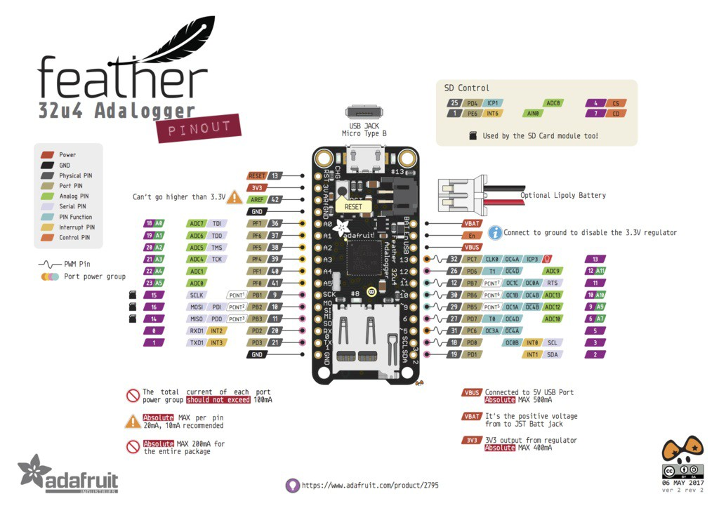

In particular the following Pins are used for the SD Card and should not be connected to the camera:

25

1

4 CS

7 CD

## Programming

In order to be able to control the Camera from Arduino you will need to install the following library:

[VC0706 Library](https://github.com/adafruit/Adafruit-VC0706-Serial-Camera-Library)

Once the library is installed you should open the File > Examples > Adafruit VC0706 Serial Camera Library > MotionDetect and flash it to the board.

Now find the line:

#define chipSelect 10

And change this to the CS pin, in our case is 4. Finally update the serial connection pins, to the ones you choose during the wiring:

SoftwareSerial cameraconnection = SoftwareSerial(2, 3);

The library has a useful function for detecting motion cam.motionDetected() . Each time it detects the motion a new JPG image is saved on the SD Card.

Check out the example for the full documentation.

## Enclosure

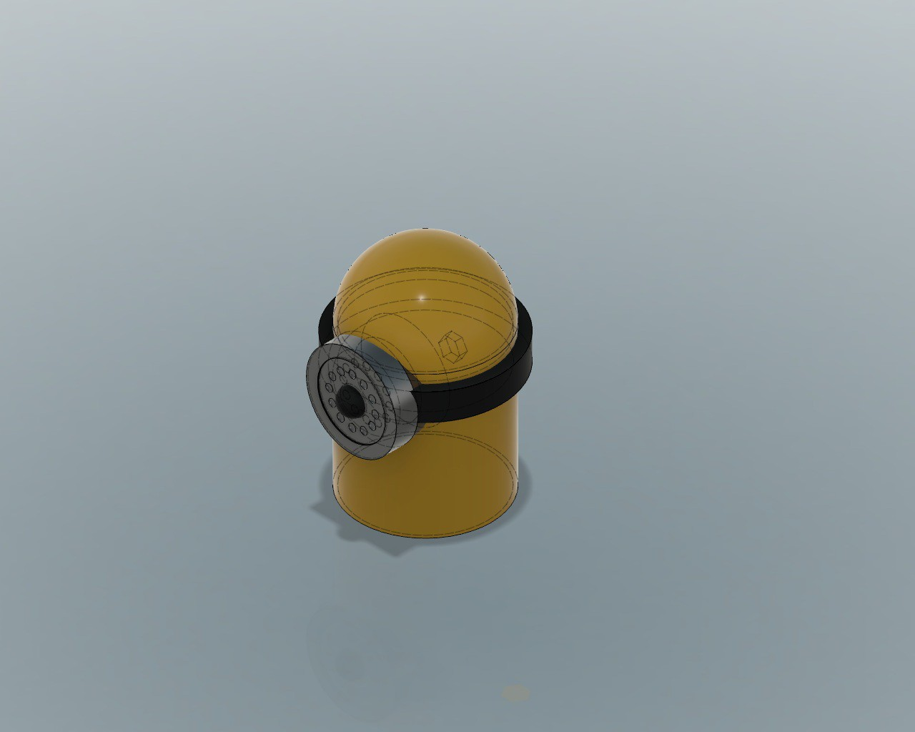

Given the project requirements we designed a Minion Enclosure, you can find the source in the [Fusion 360 Archive](http://a360.co/2vG3kJy)

# DESKTOP ROBOTIC LAMP

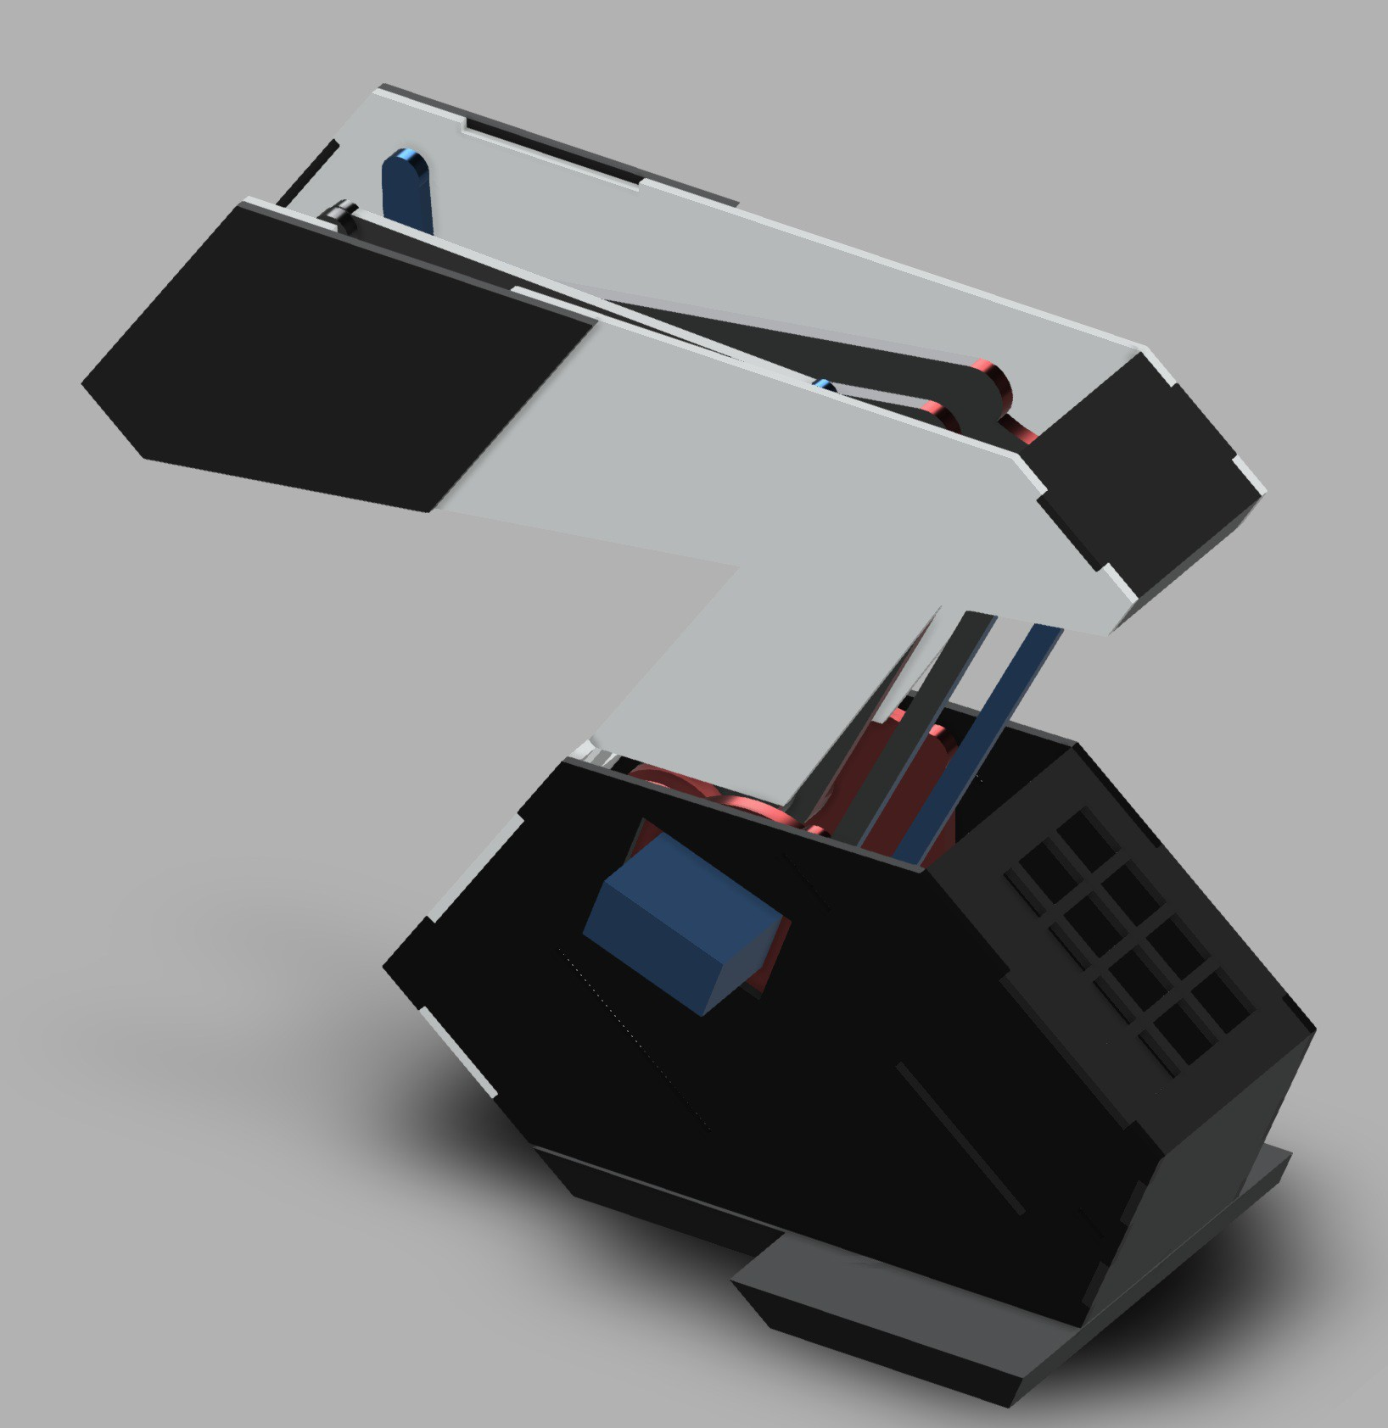

Lampus Company is looking for a robotic desktop lamp which is able to play and draw using light.

We selected the uArm project as a basis in order to make a four-axis robot lamp which can easily move and light in multiple directions.

The lamp must be equipped with a lampshade, made of wood or plastics, and a solid base for embedding the electronics.

The final user should be able to select between different modes of operation using a simple interface.

The design of the lamp should be parametric, based on the size of the robot, quantity of LEDs and material thickness.

The project should include the product concept statement and its documentation in order to easily replicate the product in any lab.

## PRODUCT REQUIREMENTS

Easily replicable in any lab in maximum 4 hours Lampshade made of wood or plastics

Interface for setting modes of operation Parametric model

Fancy lighting effects

## MACHINES AND TOOLS

3D Printer Laser cutter

Precision CNC Mill, i.e. Roland SRM-20 Soldering iron

## BILL OF MATERIALS

Robotic Arm kit, for example [Sainsmart](https://www.sainsmart.com/collections/robotics-cnc/products/4-axis-desktop-robotic-arm-assembled)

NeoPixel LED Strip

Arduino-compatible board.

Materials for the enclosure: PLA, ABS - or Natural fiber composite, Wood, Acrylic

[Adafruit 16-Channel 12-bit PWM/Servo Driver - I2C interface - PCA9685](https://www.adafruit.com/product/815)

## Servo specs

### MG995 Servo:

Size: 40.7*19.7*42.9mm

Working torque: 13kg/cm

16*7.8*16.9 inch

Respond rotation speed: 53-62R/M

Working temperature: -30~+60 -22 ~+140 Dead zone: 4ms

Plug: JR, Futaba

Rotation angle: 180 degree Analog servo

Working current: 100mA Working voltage: 3-7.2V

Metal gear, coreless motor, two ball bearing

Operation speed: 0.17s/60degree(4.8V); 0.13S/60degree(6.0V)

**SG90 Servo:**

Size: 23*12.2*29mm 0.9*0.5*1.1inch Weight: 9g

Working torque: 1.6kg/cm

Respond rotation speed: 0.12-0.13s/60degree Working temperature: -30~+60 -22 ~+140 Dead zone: 5ms

Plug: JR, Futaba

Rotation angle: 180 degree Analog servo

Working current: 100mA Working voltage: 3.5-6V Metal gear

**Building instructions**

The robot arm should come assembled. In any case the robot needs to be assembled before the workshop, so participants can focus on the design.

The robot arm comes with four wires, each for one of the servo motors controlling the arm movement.

You need to connect the servo motors with the servo driver board and the latter with the Arduino board, according to the following:

1. Prepare the driver board soldering the pins.

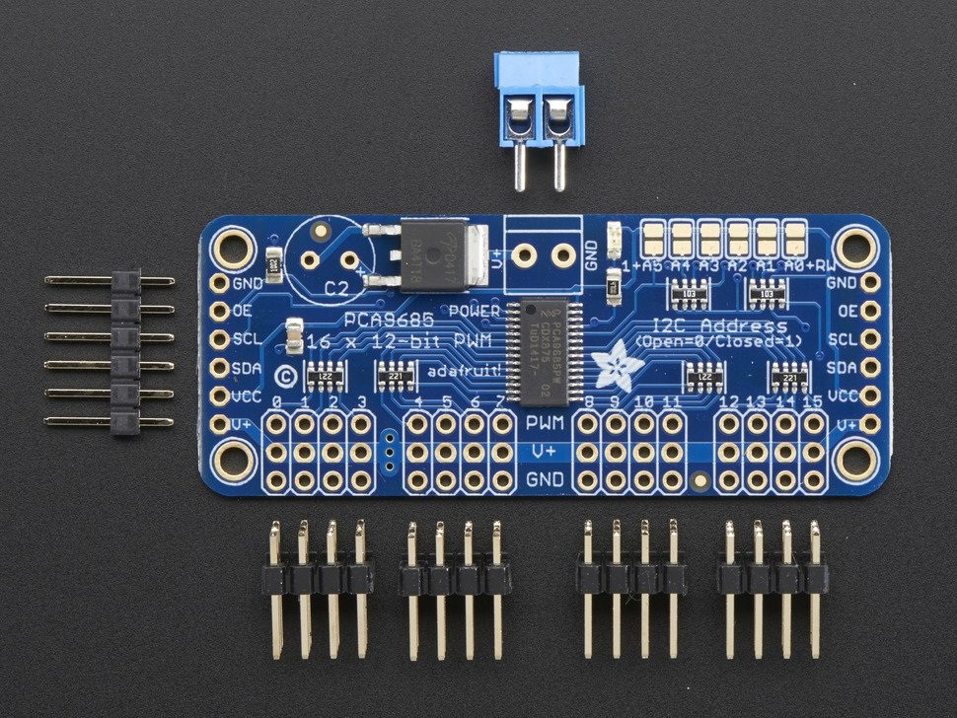

1. Connect the servo motors to the pins, starting from left (0) with the bottom servo connector, and moving from bottom to top in numbering them. Ground wire (usually black or brown) with the bottom row and the signal wire (usually yellow or white) on the top, and red in the middle.
2. Connect the I2C wires from the driver board to Arduino

SCL -> SCL Arduino UNO (old Analog 5) SDA -> SDA Arduino UNO (old Analog 4 ) GND -> GND

VCC -> 5V Arduino pin

This will power only the board, not the servo.

1. Connect power to the servo. You can use a 5V power supply, a 4xAA battery holder. Anything from 5V to 6-7v should be fine. Don't turn on power yet.

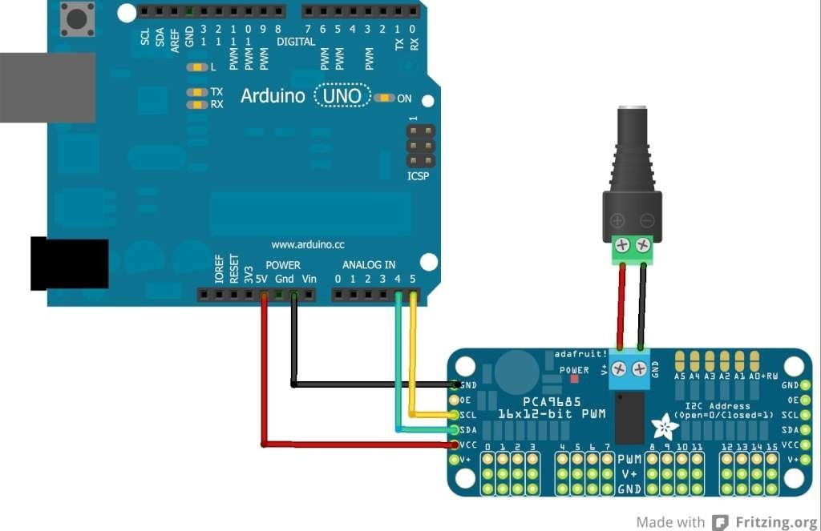

## Enclosure

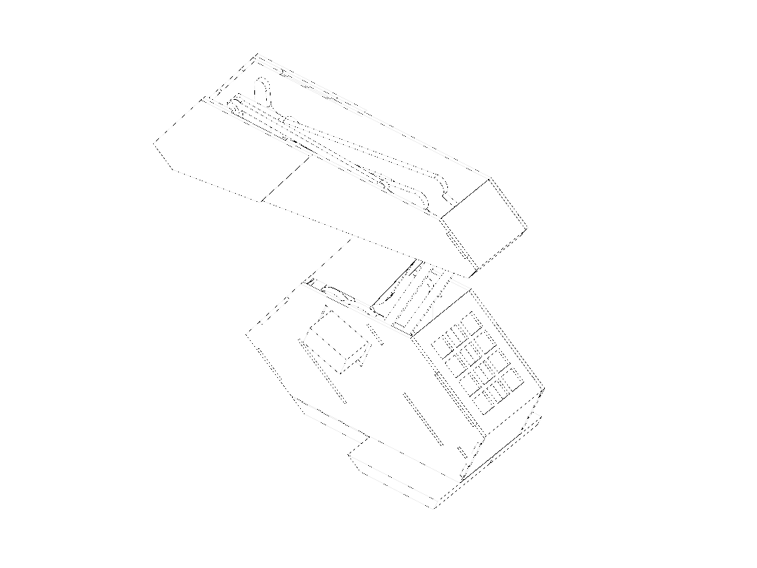

You can find a design for the Enclosure in the Fusion 360 Shared folder, or at this link:

<http://a360.co/2wBNvkb>

## Programming

### Preparation

You need to install the Adafruit PWM Servo Driver Library: <https://github.com/adafruit/Adafruit-PWM-Servo-Driver-Library> Start conecting only the servo number 0, to test the wiring.

### Calibration

Loading the Servo Example (File->Examples->Adafruit_PWMServoDriver->Servo) in the board should make the servo move back and forth of 180 degrees.

Now you can do a calibration adjusting the numbers in SERVOMIN and SERVOMAX. Make small changes and test you cover all 180 degrees.

### Programming

The Servo library uses pulse timing for operating the servo. Once calibration is done, you can use the following function to get the required pulse length from degrees:

pulselength = map(degrees, 0, 180, SERVOMIN, SERVOMAX);

You can also set the pulse frequency, the servos used in the project work well with 1ms.

pwm.setPWMFreq(1000)

Add to the Servo Example a function like the following:

void setServo(uint8_t n, uint8_t degrees){

pwm.setPWM(n, 0, map(degrees, 0, 180, SERVOMIN, SERVOMAX));

}

and you can control individually the servos starting from degrees.

### Exercise

Build a keypad controller like the following:

A button, each time is pressed allows to select which servo to use

Two buttons on the size, that increment or decrement the selected servo position

Tip: Set a variable for the current servo number and limit it to the number of servos (reset to 0). Each time the button is pressed increment it

Tip: Make an Array containing the current degrees for each servo. Update the array with the button presses incrementing and decrementing the position. Then write in the loop() the position of all servos.

Extra: Add one LED per servo, and light the right one

## Controlling the Lamp

You can decorate the tip of the Robotic arm and its body with the Neopixel strip.

You need to connect the strip to Arduino. The strip has arrows, so you should find the direction of the arrow and connect an Arduino Pin to the IN pad on the strip. Wire also the GND (-) and 5V (+) pads on the strip. If you use a long strip you should supply 5V from an external source, still connecting a common GND to Arduino.

You need to install the following library:

[Adafruit NeoPixel Library](https://github.com/adafruit/Adafruit_NeoPixel)

You can test the LED strip with the following simple code, change the PIN where you connected the NeoPixels:

#include <Adafruit_NeoPixel.h>

// update these two defines below

#define PIN

6

#define N_LEDS 144

Adafruit_NeoPixel strip = Adafruit_NeoPixel(N_LEDS, PIN, NEO_GRB + NEO_KHZ800); void setup() {

strip.begin();

}

void loop() {

chase(strip.Color(255, 0, 0)); // Red

chase(strip.Color(0, 255, 0)); // Green

chase(strip.Color(0, 0, 255)); // Blue

}

static void chase(uint32_t c) {

for(uint16_t i=0; i<strip.numPixels()+4; i++) { strip.setPixelColor(i , c); // Draw new pixel strip.setPixelColor(i-4, 0); // Erase pixel a few steps back strip.show();

delay(25);

}

}

Tip: You can add another button that cycles different states for the lamp. Store the state in an int variable, if it's 0 you will switch the lamp off (set the color to rgb= (0,0,0)), otherwise you'll play a different sequence or a different color

# VACUUM FORMER

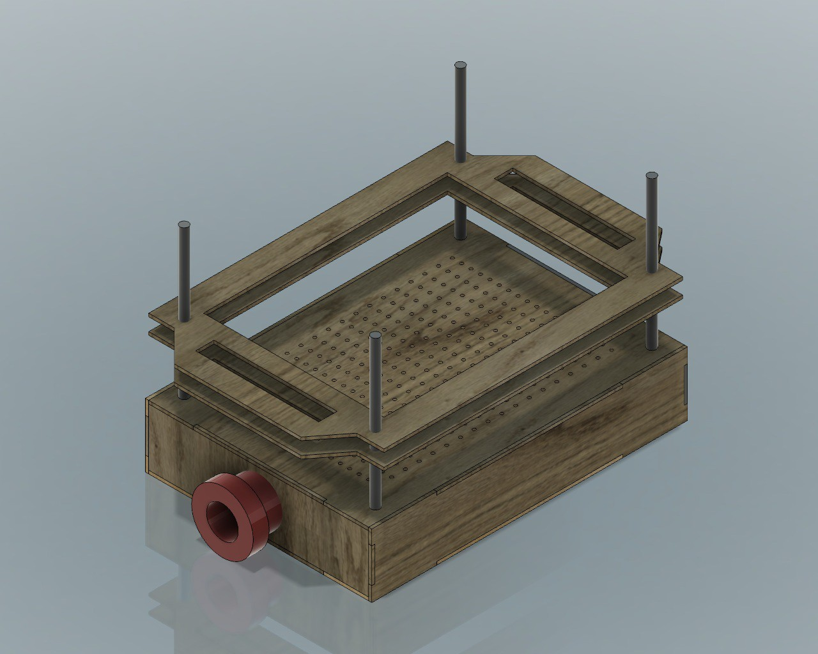

Vacuum Company is looking for a vacuum former machine which allows people to easily pack their stuff.

The product should be affordable and portable.

The design should be prototyped using laser cutting technology and include 3D printed parts. We recommend to use plywood or plexiglass and plastics to make the product as affordable as possible.

Designer should prototype their concept proposal in 4 hours maximum using the start files provided.

The project should include the product concept statement and its documentation in order to easily replicate the product in any lab.

# PRODUCT REQUIREMENTS

Easily replicable in any lab in maximum 4 hours Easy to use

Made of plywood and plastics Parametric model

Affordable

# MACHINES AND TOOLS

Laser cutter 3D printer Vinyl cutter

1000w Vacuum cleaner

# BILL OF MATERIALS

Plywood Plexiglass

ABS / PLA Filament Vinyl

## Building instructions

You can build the Vacuum Former from the following [Fusion 360 Model](http://a360.co/2iWRcxN)

In the folder you can find a Parametric design that can be customized to make an arbitrary size. The wider the bed, the more powerful the vacuum should be.

For Laser Cutting you can export the shapes for all bodies and create a layout on a piece of wood or acrylic.

3D Print the hose connector adapting it to the size of your vacuum cleaner.

## Operating instructions

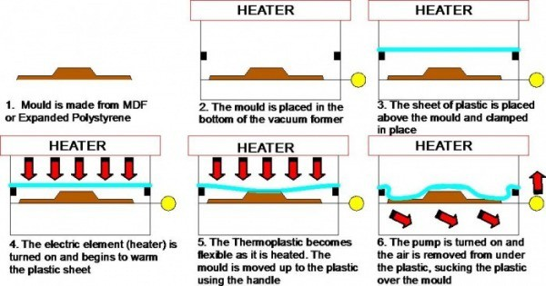

Place a small object on the bed. Make sure it doesn't melt when heated for short periods of time to more than 100c

Place a sheet of PETG between the frame, cut it at size in a way that doesn't cover the screw holes

Position the frame using the reference screws as shown in the figure at the top of the page

Heat up the PETG sheet using an heat-gun for PCBs. Wait till the PETG sheet bends significantly.

Move the frame towards the bed and quickly turn on the vacuum cleaner, keep heating the sheet when it doesn't completely stick to the bed.

## Expected results

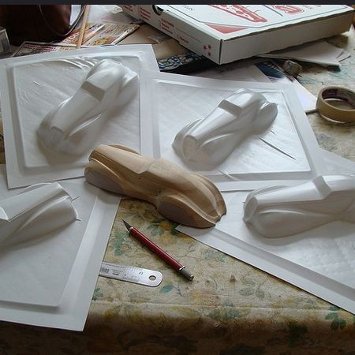

**References**

[Formech Discover Vacuum Forming](https://youtu.be/YJ2khPSVYoo) [Thermoformed](http://lettucebranch.blogspot.it/2011/06/diy-vacuum-former-for-thermoformed.html)

# DRAW BOT

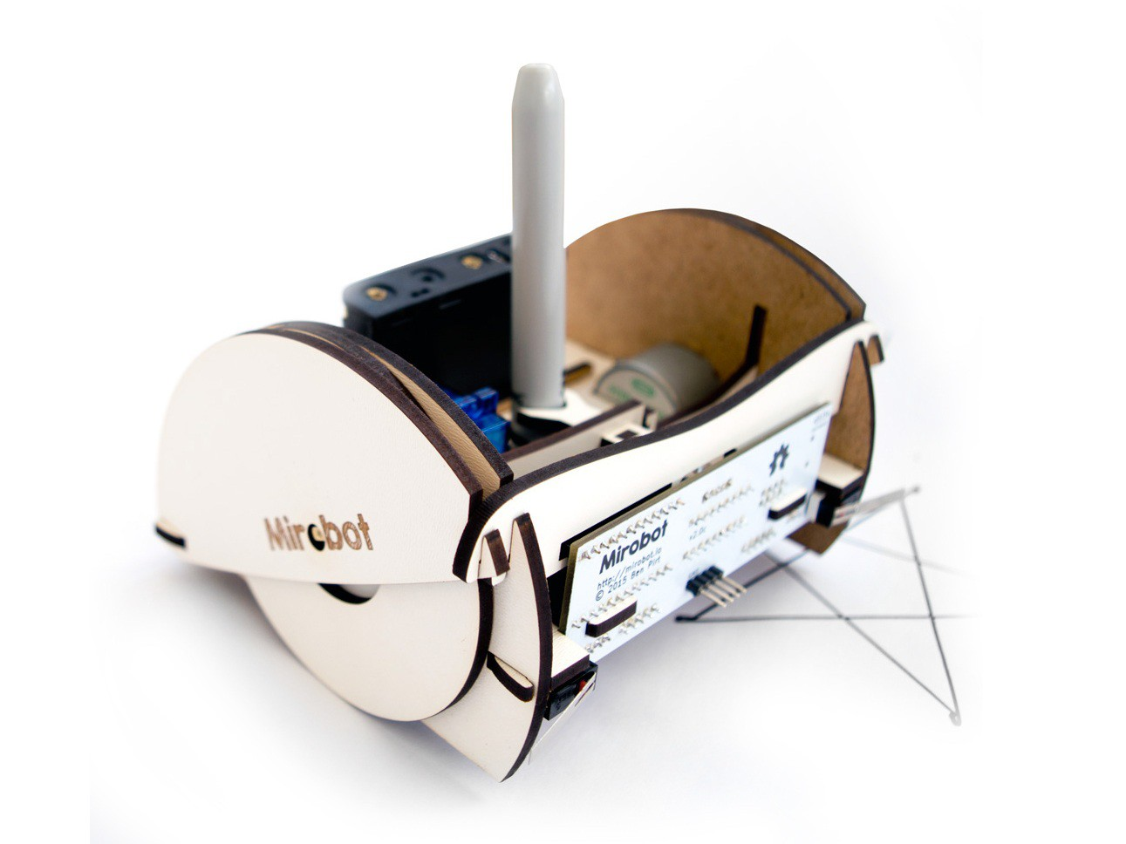

DOT Corporation is looking for a new kind of robot which can draw and write.

The robot should be user friendly and suitable for kids. It should be also affordable and as small as possible.

The design can be prototyped using laser cutting technology and it should include 3D printed parts.

Designer should prototype their concept proposal in 4 hours maximum using the Open Source Drawbot structure provided.

The project should include the product concept statement and its documentation in order to easily replicate the product in any lab.

## PRODUCT REQUIREMENTS

As small as possible

User friendly Affordable

Made using laser cutter and 3D printer

## MACHINES AND TOOLS

3D Printer Laser cutter

Precision CNC Mill, i.e. Roland SRM-20 Soldering iron

## BILL OF MATERIALS

Plywood Machinable wax Plexiglas

ABS / PLA Filament Micro-controller Motors

## Building instructions

The project is based on the open-source Mirobot, that uses an Arduino Pro Mini and an ESP8266 for Wifi Control of the robot abilities. All components are integrated in a single board for convenient assembly.

The project includes two DC motors, and a Servo motor controlling the pen.

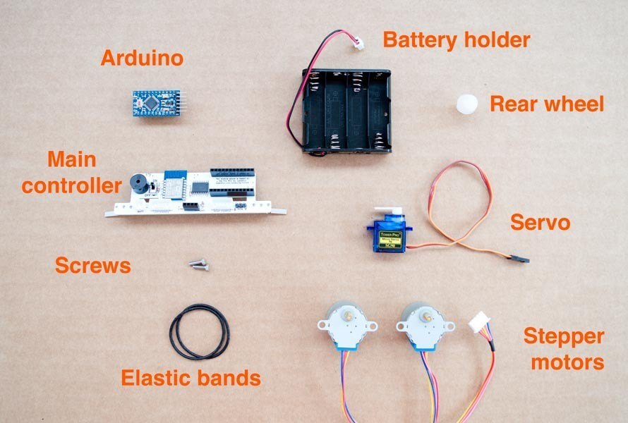

Once assembled you are ready to go.

## Custom design

You can customize the design starting from the [source files](https://github.com/fablabmade/mirobot-chassis) for the chassis, editable in illustrator or ready to cut.

The [PCB is also open source](https://github.com/fablabmade/mirobot-pcb), and add-on boards are also provided for line following and programming ESP8266.

Finally you can start from the following [Fusion 360 Design](http://a360.co/2eykNs0) for redesigning the robot in 3D.

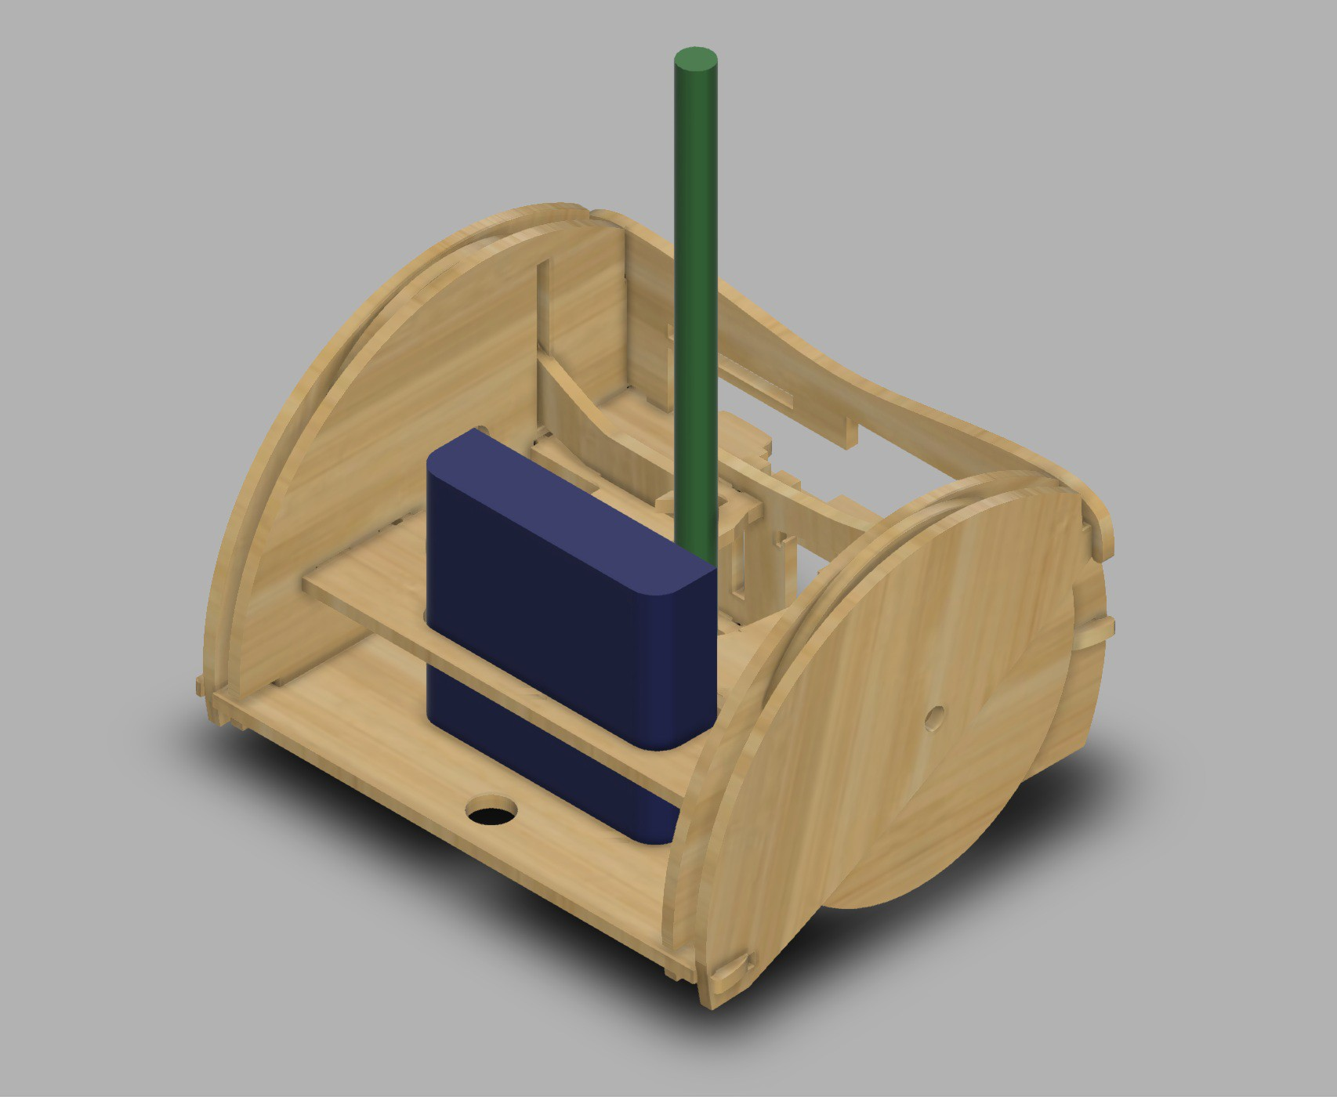

## Programming

Mirobot comes pre-programmed. In the Github repository you can find the ESP8266 and Arduino firmware.

It's easy to control the Mirobot using the provided Web interface, available after connecting to the WiFi network the Mirobot creates when switched on.

The interface is very similar to Scratch sketches, using visual blocks for robot actions.

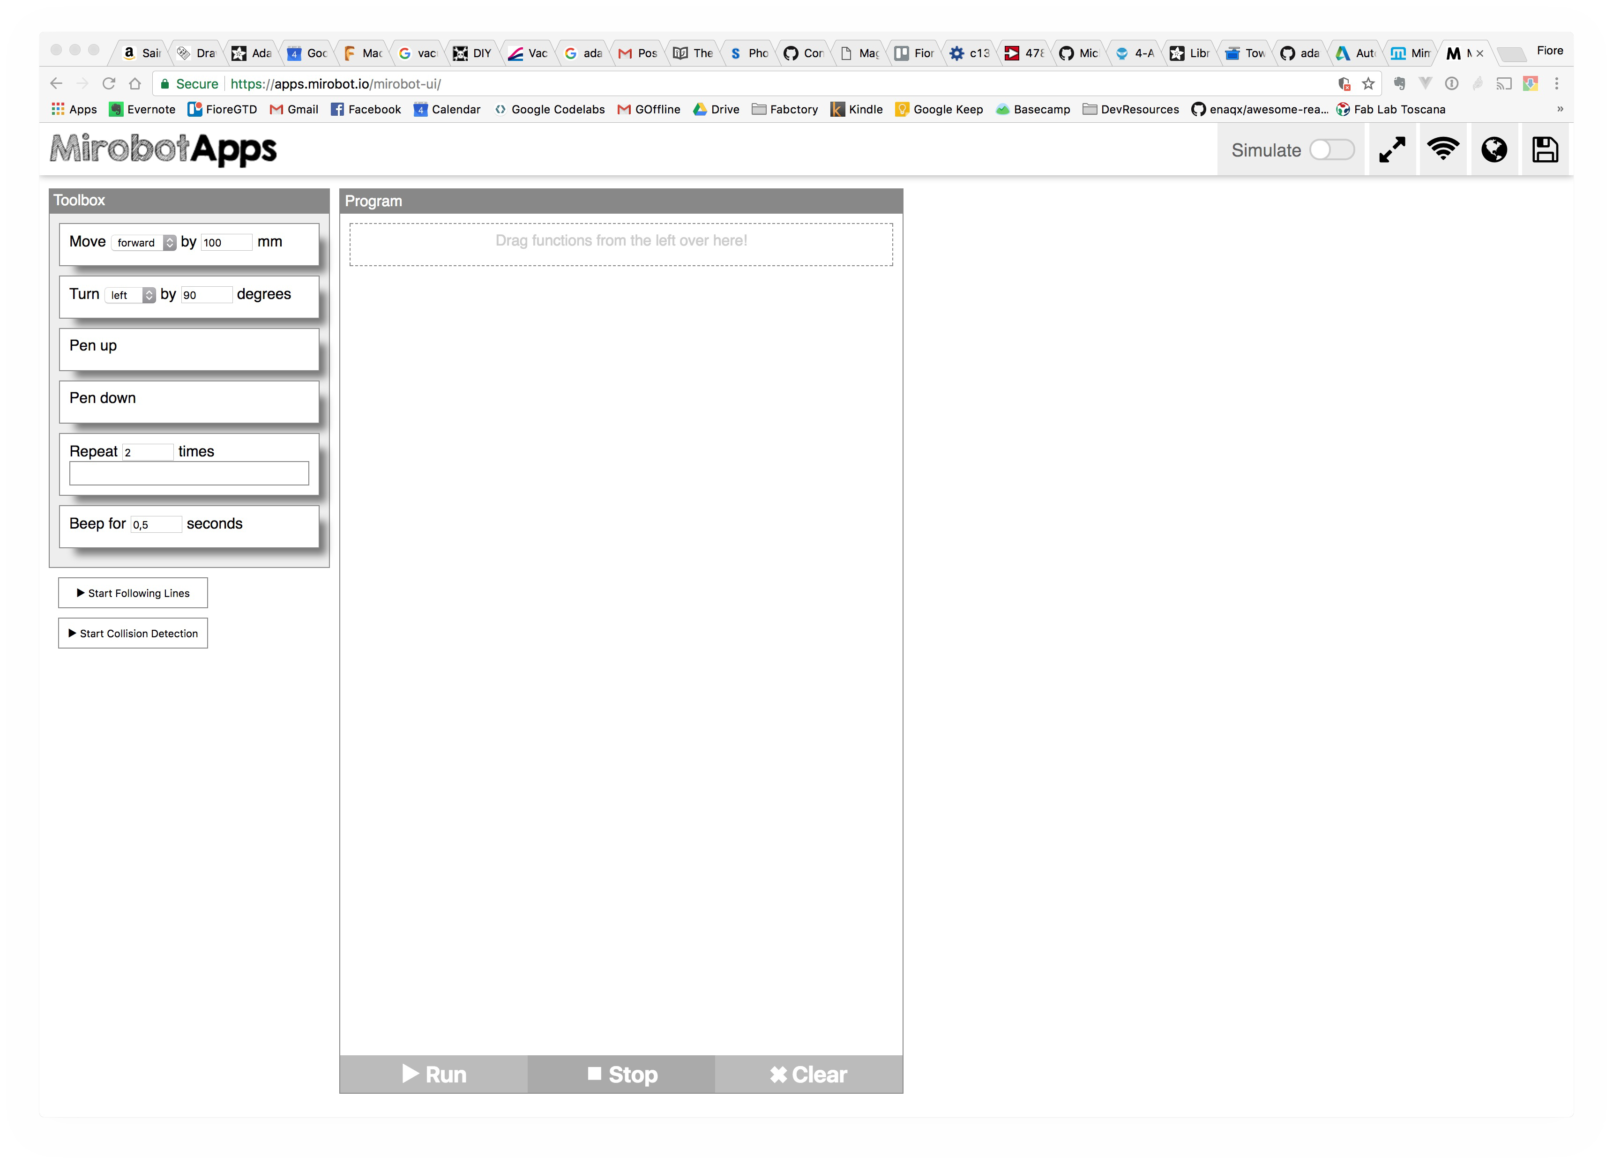

It is also possible to program the Mirobot using the [Python Library](https://github.com/mirobot/mirobot-py)

from mirobot import Mirobot

# Connect to Mirobot mirobot = Mirobot() mirobot.autoConnect()

# Put the pen down mirobot.pendown()

# Move forward 100mm mirobot.forward(100)

# Move back 100mm mirobot.back(100)

# Turn left 45 degrees mirobot.left(45)

# Turn right 45 degrees mirobot.right(45)

# Lift the pen up mirobot.penup()

# Beep for a second mirobot.beep(1000)

# Print the state of the collision sensors print(mirobot.collideState())

# Print the state of the line following sensors print(mirobot.followState())

# Disconnect from Mirobot mirobot.disconnect()

## Google Chrome extension

Using the [extension](https://chrome.google.com/webstore/detail/mirobot/bjkfmkklaabeoomedlpgfplgndpiijea) it's possible to load Mirabot apps directly from the browser into the robot:

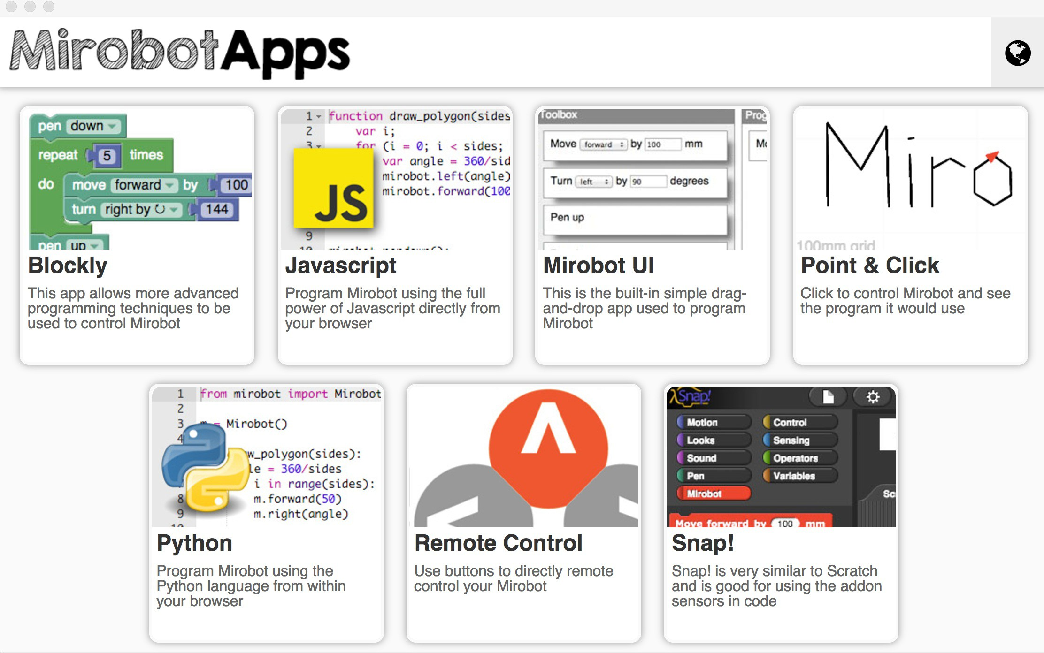

## References

[Mirobot](https://mime.co.uk/products/mirobot/) Github archive